** MINISTRY OF EDUCATION AND TRAINING**

**FPT UNIVERSITY**

Capstone Project Document

Smart Buy

|  |  |
| --- | --- |
| **Group 1** | |
| **Group member** | Doan Ho Anh Triet – Team Leader – SE60763  Huynh Thanh Viet – Team Member - SE60666  Dang Huu Hoang – Team Member - 60486  Tran Trung Dung – Team Member - 60236 |
| **Supervisor** | Mr. Kieu Trong Khanh |
| **Ext. Supervisor** | N/A |
| **Capstone Project code** | SmartB |

-Ho Chi Minh City, 02/2014-

*This page is intentionally left blank*

***ACKNOWLEDGEMENTS***

We wish to thank various people for their contribution to this project: Our teachers for their advice and participation in the final review, our friends for their valuable technical support.

Special thanks should be given to Mr.Kiều Trọng Khánh, our research supervisor for his professional guidance and the useful, constructive recommendations throughout the course of this project.

# Table of Contents

Table of Contents 4

List of Tables 5

List of Figures 7

Definitions, Acronyms, and Abbreviations 9

Report No.3 Software Requirement Specification 10

1. User Requirement Specification 10

1.1 Guest Requirement 10

1.2 Instructor Requirement 10

1.3 Staff Requirement 10

1.4 Student Requirement 10

1.5 Admin Requirement 10

1.6 System Requirement 10

2. System Requirement Specification 10

2.1 External Interface Requirement 10

2.2 System Overview Use Case 11

2.3 List of Use Case 12

3. Software System Attribute 83

3.1 Usability 83

3.2 Reliability 83

3.3 Availability 83

3.4 Security 83

3.5 Maintainability 83

3.6 Portability 83

3.7 Performance 83

4. ERD 84

# List of Tables

Table 1: <Admin> Add Image for Single Student 13

Table 2: <Admin> Add Image for Multi Students 16

Table 3: <Admin> Remove Student Images 18

Table 4: <Admin> Create Account 20

Table 5: <Admin> Active Account 21

Table 6: <Admin> Inactive Account 23

Table 7: <Admin> Config System 24

Table 8: <System> Face Detection 26

Table 9: <System> Recognize Student 27

Table 10: <System> Auto Free Storage Space 28

Table 11: <System> Auto Active Roll Call 29

Table 12: <System> Auto Inactive Roll Call 31

Table 13: <Staff>Add Roll Call 33

Table 14: <Staff>Edit Roll Call 36

Table 15: <Staff> Add Subject 37

Table 16: <Staff> Edit Subject 39

Table 17: <Staff> Active Subject 41

Table 18: <Staff> Inactive Subject 42

Table 19: <Staff> Add Student 44

Table 20: <Staff> Edit Student 47

Table 21: <Staff> Import Student List 48

Table 22: <Staff>Add Instructor 50

Table 23: <Staff> Edit Instructor 52

Table 24: <Staff> Add Class 54

Table 25 <Staff> Edit Class 55

Table 26: <Staff> Report Attendance by Class 57

Table 27: <Staff> Report Attendance by Student 58

Table 28: <Staff> Report Attendance by Block 60

Table 29: <Staff> Report Attendance by Semester 61

Table 30: <Instructor> Check Attendance by Taking Picture 65

Table 31: <Instructor> Check Attendance Manually 68

Table 32: <Instructor> View Roll Call List 70

Table 33: <Instructor> Report Attendance by Class 72

Table 34: <Student> CheckPresent Rate 74

Table 35: <Guest> Login 78

Table 36: < Authorized User> Change Password 80

Table 37: <User> Logout 82

# List of Figures

Figure 1: System Overview Use Case 10

Figure 2: <Admin> Overview Use Case 11

Figure 3: <Admin> Add Image for Single Student 11

Figure 4: <Admin> Add Image for Multi Student 14

Figure 5: <Admin> Remove Student Image 16

Figure 6: <Admin> Create Account 18

Figure 7: <Admin> Active Account 20

Figure 8: <Admin> Inactive Account 21

Figure 9: <Admin> Config System 23

Figure 10: <System> Overview Use Case 24

Figure 11: <System> Face Detection 25

Figure 12: <System> Recognize Student 26

Figure 13: <System> Auto Free Storage Space 28

Figure 14: <System> Auto Active Roll Call 29

Figure 15: <System> Auto Inactive Roll Call 30

Figure 16: <Staff> Overview Use Case 31

Figure 17: <Staff>Add Roll Call 31

Figure 18: <Staff>Edit Roll Call 34

Figure 19: <Staff> Add Subject 36

Figure 20: <Staff> Edit Subject 38

Figure 21: <Staff> Active Subject 39

Figure 22: <Staff> Inactive Subject 41

Figure 23: <Staff> Add Student 43

Figure 24: <Staff> Edit Student 45

Figure 25: <Staff> Import Student List 47

Figure 26: <Staff>Add Instructor 49

Figure 27: <Staff>Edit Instructor 50

Figure 28: <Staff> Add Class 52

Figure 29: <Staff> Edit Class 54

Figure 30: <Staff> Report Attendance by Class 56

Figure 31: <Staff> Report Attendance by Student 57

Figure 32: <Staff> Report Attendance by Block 59

Figure 33: <Staff> Report Attendance by Semester 60

Figure 34: <Staff> Export Report 62

Figure 35: <Instructor> Overview Use Case 63

Figure 36: <Instructor> Capture and Show result attendance 63

Figure 37: <Instructor> Check Attendance Manually 66

Figure 38: <Instructor> View Roll Call List 69

Figure 39: <Instructor> Report Attendance by Class 71

Figure 40: <Student> Overview Use Case 72

Figure 41: <Student> CheckPresent Rate 73

Figure 42: <Guest> Overview Use Case 77

Figure 43: <Guest> Login 77

Figure 44: < Authorized User> Overview Use Case 79

Figure 45: < Authorized User> Change Password 79

Figure 46: < Authorized User> Logout 81

Figure 47: ERD - Conceptual Diagram 83

# Definitions, Acronyms, and Abbreviations

|  |  |
| --- | --- |
| SmartB | Smart Buy |

# Report No.3 Software Requirement Specification

## User Requirement Specification

### Guest Requirement

Guest is a person who doesn’t have access to the system. Guest can use some functions in the system. To use all functions, guest must login. These are some functions guest can use:

* Register.
* Ask for system suggestion.
* Search product.
* Add product to cart.

### Member Requirement

Member is guest who uses his account to login to the system. Member can use additional functions, such as:

* Update product price.
* Save product history.

### Staff Requirement

Staff is the person who manages the system. Staff can use these function:

* Configure system.
* Make statistics.
* Manage market.
* Manage user.
* Manage product.

### System Requirement

System is also an actor, run in the background to keep the system working. System can do functions:

* Parse data.

## System Requirement Specification

### External Interface Requirement

#### User Interface

* + The interface of website is clear, do not annoy customer.
  + The interface of mobile app must be clear, compatible with touch screen. The size of controls must be big enough to touch on smartphone.
  + The error, warning messages must be make clear, easy to understand. Error warning does not disturb customer.

#### Hardware Interface

* + The system will use the standard hardware and data communications resources of a standard computer.

#### Software Interface

* + Firefox Browser, Chromes with Resolution (1280*800) or bigger and support JavaScript and HTML5
  + Smartphone with Android 4.1 or above. Screen size (70 x 120 mm) or bigger.

#### Communication Protocol

* Website using HTTP protocol for communication between the web browser and the web server.
* Mobile app using HTTP protocol for communicating between app and web service.

### System Overview Use Case

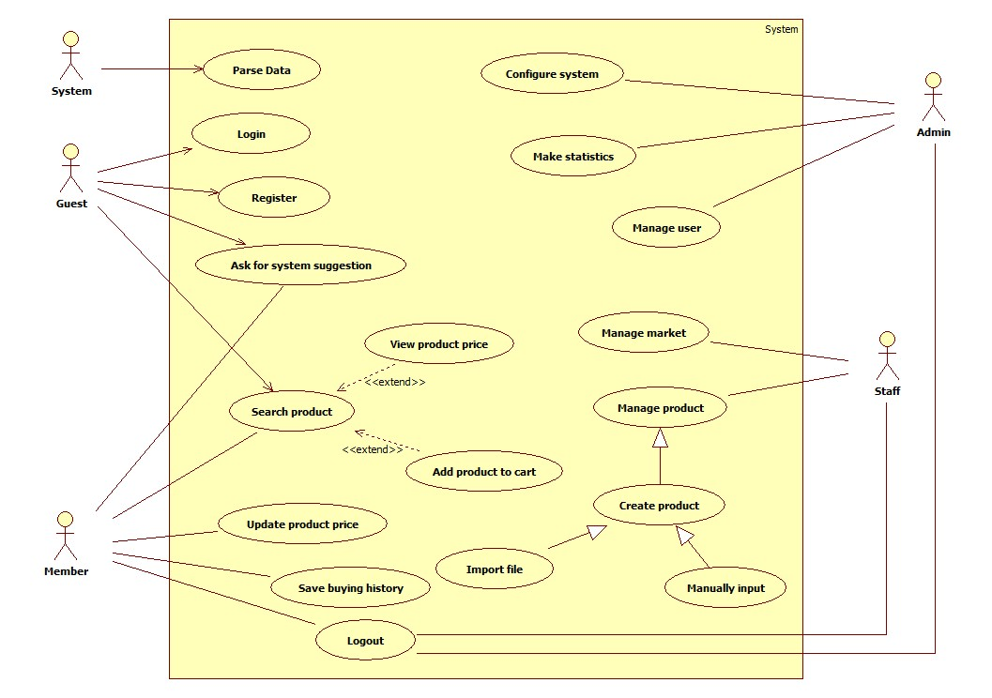

Figure 1: System Overview Use Case

### List of Use Case

#### Admin Use Cases

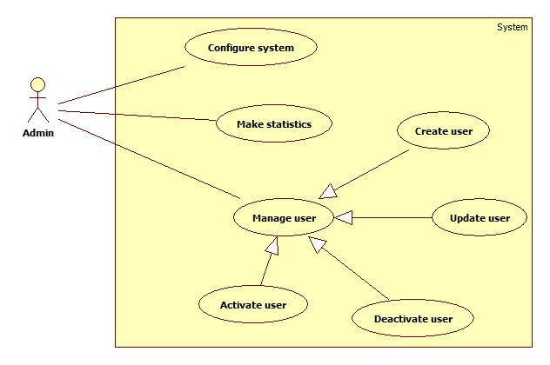

Figure 2 - <Admin> Overview usecase

##### <Admin> Configure system

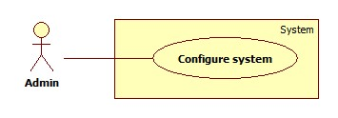

Figure 3: <Admin> Configure system

|  |  |  |  |
| --- | --- | --- | --- |
| **USE CASE – SB001** | | | |
| **Use Case No.** | SB001 | **Use Case Version** | 2.0 |
| **Use Case Name** | Configure system | | |
| **Author** | Doan Ho Anh Triet | | |
| **Date** | 15/02/2014 | **Priority** | High |
| **Actor:**   * Admin   **Summary:**   * This use case allows admin to configure the system.   **Goal:**   * System parameters will be configured by admin.   **Triggers:**   * Admin wants to change system parameter, such as epsilon number or parse time. * To go to “System Configuration” screen, admin clicks at “System configuration” menu.   **Preconditions:**   * User must login into the system with the admin role.   **Post Conditions:**   * **Success:** New parameter will be saved to configuration file. * **Fail:** Nothing is saved to configuration file.   **Main Success Scenario:**   |  |  |  | | --- | --- | --- | | Step | Actor Action | System Response | | 1 | Click at “System Configuration” link in the menu. | Show “System Configuration” page which contains:   * Epsilon: textbox, min length: 1, max length: 3, type: integer number, min value: 1, max value: 100, required. * Thời gian parse: time picker, min value: 0:00, max value: 23:59, required. * Lưu: button. | | 2 | Admin changes system parameters. |  | | 3 | Click on “Lưu” button.  [Exception 1, 2, 3] | * Save data to configuration file. * Show success message. |   **Alternative Scenario:** N/A  **Exceptions:**   |  |  |  | | --- | --- | --- | | No | Actor Action | System Response | | 1 | Epsilon value out of range. | Show error message: “Epsilon phải lớn hơn 0 và nhỏ hơn hoặc bằng 100!” | | 2 | Epsilon is not a number. | Show error message: “Epsilon phải là số!” | | 3 | Time format is not correct. | Show error message: “Thời gian phải đúng định dạng!” |   **Relationships:** N/A  **Business Rules:** N/A | | | |

Table 1: <Admin> Configure System

##### <Admin> Make statistics

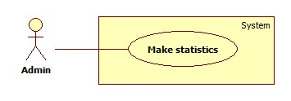

Figure 4: <Admin> Make statistics

|  |  |  |  |
| --- | --- | --- | --- |
| **USE CASE – SB002** | | | |
| **Use Case No.** | SB002 | **Use Case Version** | 2.0 |
| **Use Case Name** | Make statistics | | |
| **Author** | Doan Ho Anh Triet | | |
| **Date** | 15/02/2014 | **Priority** | Normal |
| **Actor:** Admin  **Summary:**  **Goal:**  **Triggers:**  **Preconditions:**   * User must login into the system with admin role.   **Post Conditions:**   * **Success:** * **Fail:**   **Main Success Scenario:**   |  |  |  | | --- | --- | --- | | Step | Actor Action | System Response | | 1 |  |  |   **Alternative Scenario:**   |  |  |  | | --- | --- | --- | | No | Actor Action | System Response | | 1 |  |  |   **Exceptions:**   |  |  |  | | --- | --- | --- | | No | Actor Action | System Response | | 1 |  |  |   **Relationships:**  **Business Rules:** | | | |

Table 2: <Admin> Make statistics

##### <Admin> Create user

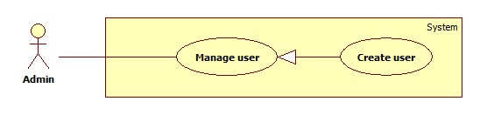

Figure 5: <Admin> Create user

|  |  |  |  |
| --- | --- | --- | --- |
| **USE CASE – SB003** | | | |
| **Use Case No.** | SB003 | **Use Case Version** | 2.0 |
| **Use Case Name** | Create user | | |
| **Author** | Doan Ho Anh Triet | | |
| **Date** | 15/02/2014 | **Priority** | Normal |
| **Actor:**   * Admin   **Summary:**   * This user case allows admin to create new user account for the system.   **Goal:**   * New user account will be added to the system.   **Triggers:**   * Admin wants to create new user account. * Navigate to “Quản lý tài khoản” and click “Tạo tài khoản” button.   **Preconditions:**   * User must login into the system with admin role.   **Post Conditions:**   * **Success:** New user account will be added to the database. * **Fail:** Nothing is added to the database.   **Main Success Scenario:**   |  |  |  | | --- | --- | --- | | Step | Actor Action | System Response | | 1 | Admin clicks “Tạo tài khoản” link. | Navigate to “Tạo tài khoản” page which contains:   * Username: textbox, min length: 6, max length: 30, required. * Password: textbox, min length: 6, max length: 20, required. * Role: drop down list, required. * Tạo tài khoản: button. * Xóa trắng: button. | | 2 | Admin fills data to the form. |  | | 3 | Admin clicks “Tạo tài khoản” button. [Alternative 1] | Insert new user account to the database and redirect to “Quản lý tài khoản” page. |   **Alternative Scenario:**   |  |  |  | | --- | --- | --- | | No | Actor Action | System Response | | 1 | Admin clicks “Xóa trắng button”. | Clear all input data. |   **Exceptions:**   |  |  |  | | --- | --- | --- | | No | Actor Action | System Response | | 1 | Length of username is not in range. | Show error message: “Độ dài username phải từ 6-30 ký tự!” | | 2 | Length of password is not in range. | Show error message: “Độ dài password phải từ 6-20 ký tự!” | | 3 | Role is not specified. | Show error message: “Phải phân quyền cho user!” |   **Relationships:** N/A  **Business Rules:**   * Each created account must be in active state when insert to database. | | | |

Table 3: <Admin> Create user

##### <Admin> Create Account

Use Case Diagram

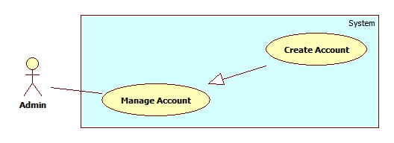

Figure 6: <Admin> Create Account

Use Case Specification

|  |  |  |  |
| --- | --- | --- | --- |
| **USE CASE – AD001** | | | |
| **Use Case No.** | AD001 | **Use Case Version** | 2.0 |
| **Use Case Name** | Create Account | | |
| **Author** | Pham Huy Hoang | | |
| **Date** | 20/09/2013 | **Priority** | Normal |
| **Actor:** Admin  **Summary:**  This user case allow admin to create an account for login the system  **Goal:**  A new account (For student, instructor or staff) will be added to database  **Triggers:**   * In our system, the account of a student or instructor is auto created when staff create new instructor/new student. This function is used to create staff, student or instructor account, in case of backup. * To create a new account, admin must: * From the admin Home Page, click the menu item “Account Manager”. * In the Account Manager Page, click on the Tab “Create Account”. * Input new account information, click “Create” to finish.   **Preconditions:**   * User must logged in the system with the role is admin   **Post Conditions:**   * **Success:** A new account will be created. The acocunt will be displayed on account list. * **Fail:** No acocunt created.Transfer to error page or still in current page.   **Main Success Scenario:**   |  |  |  | | --- | --- | --- | | Step | Actor Action | System Response | | 1 | Click menu item “Account Manager”. | Redirect to Account Manager Page, includes a panel with 2 tabs:   * Account List * Create Account   Current tab is Account List. This tab includes:   * Table with 5 column: * Account ID: label * Username: label * Email: label * Role: label * Select: checkbox * Action: dropdownlist, values: Inactive, Active. * Process: button | | 2 | Click Tab “Create Account”. | Display a tab panel includes:   * Username: textbox (min length, max length: 30, required). * Password: textbox (password box, min length, max length: 30, required). * Password: textbox (password box, min length, max length: 30, required). * Roles : dropdownlist, values: Admin, Staff, Instructor, Student. * Create: button * Reset: button | | 3 | Input new account information.  Click “Create” button.  [Alternative 1] | System will add the account to database.  Show the tab panel “Account List”  [Exception 1,2,3,4] |   **Alternative Scenario:**   |  |  |  | | --- | --- | --- | | No | Actor Action | System Response | | 1 | Click on “Reset” button | The form is emptied. |   **Exceptions:**   |  |  |  | | --- | --- | --- | | No | Actor Action | System Response | | 1 | Not enter enough require information. | Display error message: “Please enter all require information.” | | 2 | Username/password is not in range [6,30] | Display error message: “Username/Password must in range [6,30].” | | 3 | Confirm password is not equal password | Display error message:  “Password and confirm not match.” | | 4 | Username or email existed in database | Display error message:  “Username/Email already exist.” |   **Relationships:** Manage Account  **Business Rules:**   * Each account is active when added to database. * The “confirm password” value must match “password” value. | | | |

Table 4: <Admin> Create Account

##### <Admin> Active Account

Use Case Diagram

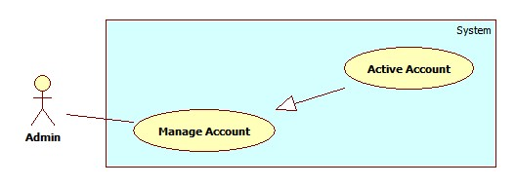

Figure 7: <Admin> Active Account

Use Case Specification

|  |  |  |  |
| --- | --- | --- | --- |
| **USE CASE – AD002** | | | |
| **Use Case No.** | AD002 | **Use Case Version** | 2.0 |
| **Use Case Name** | Active Account | | |
| **Author** | Pham Huy Hoang | | |
| **Date** | 20/09/2013 | **Priority** | Normal |
| **Actor:** Admin  **Summary:**  This user case allow admin to active an accout  **Goal:**  A inactive account will be activated  **Triggers:**   * In our system, when we do not want an user to login, we inactive his/her account (See Use Case – AD003). We can active the inactivated account so they can login again. * To active an account, admin must: * From the admin Home Page, click the menu item “Account Manager”. * Check the Select checkbox of the account record, select “Active” on the drop down list, and press “Process” button.   **Preconditions:**   * User must logged in the system with the role is admin. * There must be at least 1 inactive account in database.   **Post Conditions:**   * **Success:** The selected account(s) will be activated. * **Fail:** No acocunt activated.Transfer to error page.   **Main Success Scenario:**   |  |  |  | | --- | --- | --- | | Step | Actor Action | System Response | | 1 | Click menu item“Account Manager”. | Redirect to Account Manager Page, includes a panel with 2 tabs:   * Account List * Create Account   Current tab is Account List. This tab includes:   * Table with 5 column: * Account ID: label * Username: label * Email: label * Role: label * Select: checkbox * Action: dropdownlist, values: Inactive, Active. * Process: button | | 2 | Check the checkboxs of the account(s), select “Active” on the drop down list, and press “Process” button. | The selected account(s) will be activated  [Exception 1,2] |   **Alternative Scenario:** N/A  **Exceptions:**   |  |  |  | | --- | --- | --- | | No | Actor Action | System Response | | 1 | The account has already been activated by another admin | Nothing happen, the account(s) status is active | | 2 | Check no checkbox, press “Process” button | Display error message:  “Please select account to activated.” |   **Relationships:** Manage Account  **Business Rules:**   * Admin can’t active/inactive account of themselves or other admin. | | | |

Table 5: <Admin> Active Account

##### <Admin> Inactive Account

Use Case Diagram

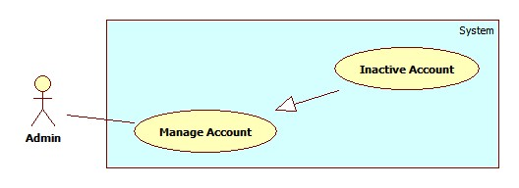

Figure 8: <Admin> Inactive Account

Use Case Specification

|  |  |  |  |
| --- | --- | --- | --- |
| **USE CASE – AD003** | | | |
| **Use Case No.** | AD003 | **Use Case Version** | 2.0 |
| **Use Case Name** | Inactive Account | | |
| **Author** | Pham Huy Hoang | | |
| **Date** | 20/09/2013 | **Priority** | Normal |
| **Actor:** Admin  **Summary:**  This user case allow admin to active an accout  **Goal:**  A active account will be inactivated  **Triggers:**   * In our system, when we do not want an user to login, we inactive his/her account. The account can be activated later. * To active an account, admin must: * From the admin Home Page, click the menu item “Account Manager”. * Check the Select checkbox of the account record, select “Active” on the drop down list, and press “Process” button.   **Preconditions:**   * User must logged in the system with the role is admin * There must be at least 1 active account in database.   **Post Conditions:**   * **Success:** The selected account(s) will be inactivated. * **Fail:** No acocunt inactivated.Transfer to error page.   **Main Success Scenario:**   |  |  |  | | --- | --- | --- | | Step | Actor Action | System Response | | 1 | Click menu item“Account Manager”. | Redirect to Account Manager Page, includes a panel with 2 tabs:   * Account List * Create Account   Current tab is Account List. This tab includes:   * Table with 5 column: * Account ID: label * Username: label * Email: label * Role: label * Select: checkbox * Action: dropdownlist, values: Inactive, Active. * Process: button | | 2 | Check the checkboxs of the account, select “Inactive” on the drop down list, and press “Process” button. | The selected account(s) will be inactivated.  [Exception 1,2] |   **Alternative Scenario:** N/A  **Exceptions:**   |  |  |  | | --- | --- | --- | | No | Actor Action | System Response | | 1 | The account has already been inactivated by another admin. | Nothing happen, the account(s) status is inactive | | 2 | Check no checkbox, press “Process” button. | Display error message:  “Please select account to inactivated.” |   **Relationships:** Manage Account  **Business Rules:**   * Admin can’t active/inactive account of themselves or other admin. | | | |

Table 6: <Admin> Inactive Account

##### <Admin> Config System

Use Case Diagram

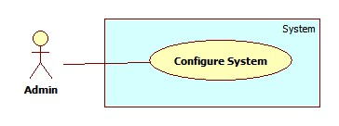

Figure 9: <Admin> Config System

Use Case Specification

|  |  |  |  |
| --- | --- | --- | --- |
| **USE CASE – AD004** | | | |
| **Use Case No.** | AD004 | **Use Case Version** | 2.0 |
| **Use Case Name** | Configure System | | |
| **Author** | Pham Huy Hoang | | |
| **Date** | 20/09/2013 | **Priority** | Normal |
| **Actor:** Admin  **Summary:**  This user case allow admin to configure system’s properties.  **Goal:**  Change current properties of the system  **Triggers:**   * For some reason, administrator needs to re-configure system’s properties. * To config the system, admin must: * Click menu item“Configuration”. * On the configuration page, edit properties and click on “Update” button corresponding with each properties in list.   **Preconditions:**   * User must logged in the system with the role is admin.   **Post Conditions:**   * **Success:** System’s properties is updated to new value. * **Fail:** Nothing changed.   **Main Success Scenario:**   |  |  |  | | --- | --- | --- | | Step | Actor Action | System Response | | 1 | Click menu item “Configuration”. | Redirect to System Configuration Page, with list of system’s properties include:   * Name: label * Value: textbox * Update: button | | 2 | Edit property value and click “Update” button. | Show confirms windows with message:  “Are you sure to change this property?” | | 3 | Click “Ok” to confirm.  [Alternative 1] | Update property value to new value. |   **Alternative Scenario:**   |  |  |  | | --- | --- | --- | | No | Actor Action | System Response | | 1 | Click “Cancel”. | Nothing happen, the value is unchanged. |   **Exceptions:** N/A  **Relationships:** N/A  **Business Rules:**   * Configure system’s properties will affect to all function using these properties.. | | | |

Table 7: <Admin> Config System

#### <System> Overview Use Case

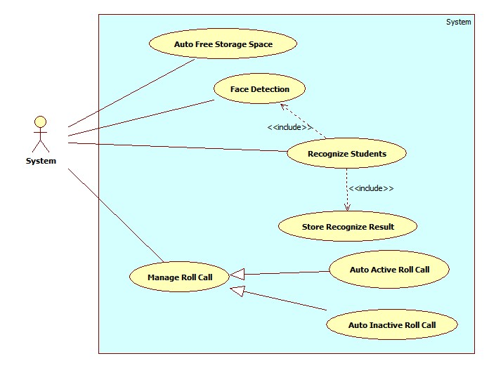

Figure 10: <System> Overview Use Case

##### <System> Face Detection

Use Case Diagram

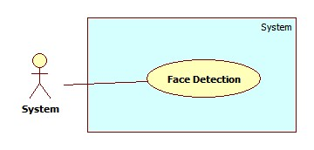

Figure 11: <System> Face Detection

Use Case Specification

|  |  |  |  |
| --- | --- | --- | --- |
| **USE CASE – SY002** | | | |
| **Use Case No.** | SY002 | **Use Case Version** | 2.0 |
| **Use Case Name** | Face Detection | | |
| **Author** | Pham Huy Hoang | | |
| **Date** | 21/09/2013 | **Priority** | High |
| **Actor:** System.  **Summary:**  This use case is used to detect the face regions in an image after it is uploaded successful.  **Goal:**  Detect the face regions in an image  **Triggers:**   * When admin upload images for Manage Student Image (See Use Case AD005, AD006), or instructor send images for Checking Attendance (See Use Case IU001), system will detect the face regions in the upload images. * The detected region will be displayed at client, or used to recognize the students in the images.   **Preconditions:**   * The images are uploaded to server successful.   **Post Conditions:**   * **Success:** The face regions is detected. Send result to front end for displaying. * **Fail:** No face detected   **Main Success Scenario:**   |  |  |  | | --- | --- | --- | | Step | Actor Action | System Response | | 1 | - Admin upload image for Manage Student Image.  Or  - Instructor send image for Checking Attendance. | Detect the face in the images, create a list of face regions. A face region’s properties:   * Top position * Left position * Height * Width   The face region can be stored as Image Data for Students, or for Student Recognition (See Use Case SY003)  [Exception 1,2] |   **Alternative Scenario:** N/A  **Exceptions:**   |  |  |  | | --- | --- | --- | | No | Actor Action | System Response | | 1 | The upload image is corrupt | Show error message: “The image XXX is corupted”. | | 2 | Upload images don’t contain human faces.  No faces detected from uploaded images. | Display error message: “ No face found. Select another images” |   **Relationships:** N/A  **Business Rules:**   * The accuracy of face detection is larger than 80%. Picture with higher brightness and resolution will has higher accuracy. * If the uploaded images are too big, the image will be resized for faster processing. | | | |

Table 8: <System> Face Detection

##### <System> Recognize Student

Use Case Diagram

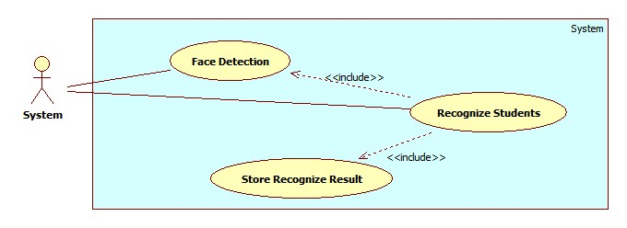

Figure 12: <System> Recognize Student

Use Case Specification

|  |  |  |  |
| --- | --- | --- | --- |
| **USE CASE – SY003** | | | |
| **Use Case No.** | SY002 | **Use Case Version** | 2.0 |
| **Use Case Name** | Recognize Student | | |
| **Author** | Pham Huy Hoang | | |
| **Date** | 21/09/2013 | **Priority** | Normal |
| **Actor:** System.  **Summary:**  This use case is used to detect the face regions in an image (for checking attendance)  **Goal:**  Detect the face regions in an image  **Triggers:**   * When instructor send images for Checking Attendance (See Use Case IU001), system will detect the face regions in the upload images. After that, the system will recognize the student present in the images. * The recognized student list will be stored as attendance log in database.   **Preconditions:**   * The images are uploaded to server successful. * The Image Data of the students must existed in database (At least 10 images). If a student doesn’t have image in database, that student will be recognized as “Unknow”   **Post Conditions:**   * **Success:** The students are recognized from images. Recognize result will be stored. * **Fail:** No student recognized. No log stored.   **Main Success Scenario:**   |  |  |  | | --- | --- | --- | | Step | Actor Action | System Response | | 1 | Instructor send image for Checking Attendance. | The same as step 1 , Use Case SY002.   * Detect face regions in the picture. * Create a face matching list. * Each face will be matched to find the face’s owner. * After recognizing, show the result and store the result to database.   [Exception 1,2,3] |   **Alternative Scenario:** N/A  **Exceptions:**   |  |  |  | | --- | --- | --- | | No | Actor Action | System Response | | 1 | The number of student detected is too small ( fewer than 5) | Show error message: “Only some students detected. Please check”. | | 2 | Find unknow people in the image | Alert: “Stranger Detected. Please check”. |   **Relationships:** Face Detection, Face Recogntion, Store Recognize Result  **Business Rules:**   * The accuracy of face recognition is 60~80%, depend on the number of image in training data. * The recommend number of image for a student is larger than10 for acceptable accuracy. * When stranger is detected, a log will be stored for later checking. | | | |

Table 9: <System> Recognize Student

##### <System> Auto Free Storage Space

Use Case Diagram

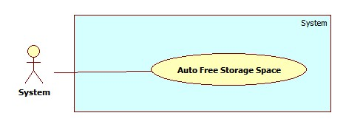

Figure 13: <System> Auto Free Storage Space

Use Case Specification

|  |  |  |  |
| --- | --- | --- | --- |
| **USE CASE – SY001** | | | |
| **Use Case No.** | SY001 | **Use Case Version** | 2.0 |
| **Use Case Name** | Auto Free Storage Space | | |
| **Author** | Pham Huy Hoang | | |
| **Date** | 21/09/2013 | **Priority** | Normal |
| **Actor:** System.  **Summary:**  This use case is used to auto free space on server  **Goal:**  Delete the image in the Temp folder to free space on server.  **Triggers:**   * When admin upload images for Managed Student Images (See Use Case AD005), those images will be stored in Temp folder. * At 0.00am, or when the size of Temp folder is bigger than 500MB, the Temp folder will be emptied for free space.   **Preconditions:** N/A.  **Post Conditions:**   * **Success:** The Temp folder is emptied. * **Fail:** No images deleted from temp folder   **Main Success Scenario:**   |  |  |  | | --- | --- | --- | | Step | Actor Action | System Response | | 1 | - Time hit 0.00am  - Size of Temp folder is bigger than 500MB | Delete all the images in Temp Folder |   **Alternative Scenario:** N/A  **Exceptions:** N/A  **Relationships:** N/A  **Business Rules:** N/A | | | |

Table 10: <System> Auto Free Storage Space

##### <System> Auto Active Roll Call

Use Case Diagram

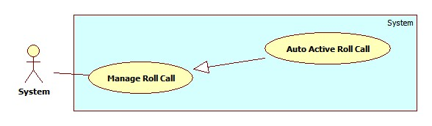

Figure 14: <System> Auto Active Roll Call

Use Case Specification

|  |  |  |  |
| --- | --- | --- | --- |
| **USE CASE – SY004** | | | |
| **Use Case No.** | SY004 | **Use Case Version** | 2.0 |
| **Use Case Name** | Auto Active Roll Call | | |
| **Author** | Pham Huy Hoang | | |
| **Date** | 21/09/2013 | **Priority** | Normal |
| **Actor:** System.  **Summary:**  This use case is used to auto active a roll call  **Goal:**  The roll call on roll call list will be activated when begin date is current date  **Triggers:**   * System will auto active a roll call when begin date is current date. * When a roll call is activated, its status in Roll Call List will be “Active”. * The instructor can only take attendance of an active roll call list.   **Preconditions:** N/A.  **Post Conditions:**   * **Success:** System will auto active a roll call. * **Fail:** No roll call activated   **Main Success Scenario:**   |  |  |  | | --- | --- | --- | | Step | Actor Action | System Response | | 1 | Roll call begin date is current date.  The system auto activate a roll call. | The roll call status become “Active”.  The roll call is show on instructor’s phone. The instructor can take attendance of the roll call. |   **Alternative Scenario:** N/A  **Exceptions:** N/A  **Relationships:** Manage Roll Call  **Business Rules:**   * A roll call has 3 status: Created, Active, Inactive. * Staff manage the info of a roll call, but staff can’t active/inactive rollcall manually. * When a roll call is Active, the staff can only Change the Instructor, or Add/Remove Student. | | | |

Table 11: <System> Auto Active Roll Call

##### <System> Auto Inactive Roll Call

Use Case Diagram

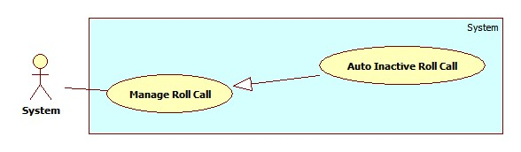

Figure 15: <System> Auto Inactive Roll Call

Use Case Specification

|  |  |  |  |
| --- | --- | --- | --- |
| **USE CASE – SY005** | | | |
| **Use Case No.** | SY005 | **Use Case Version** | 2.0 |
| **Use Case Name** | Auto Active Roll Call | | |
| **Author** | Pham Huy Hoang | | |
| **Date** | 21/09/2013 | **Priority** | Normal |
| **Actor:** System.  **Summary:**  This use case is used to auto inactive a roll call  **Goal:**  The roll call on roll call list will be inactivated when end date expired.  **Triggers:**   * System will auto inactive a roll call when end date expired. * When a roll call is inactivated, its status in Roll Call List will be “Inactive”. * The instructor can’t take attendance of an active roll call list. The staff can’t edit info of an inactive roll call.   **Preconditions:** N/A.  **Post Conditions:**   * **Success:** System will auto inactive a roll call. * **Fail:** No roll call activated   **Main Success Scenario:**   |  |  |  | | --- | --- | --- | | Step | Actor Action | System Response | | 1 | Roll call end date expired. The system auto inactivate a roll call. | The roll call status become “Inactive”.  The roll call not show instructor’s phone. |   **Alternative Scenario:** N/A  **Exceptions:** N/A  **Relationships:** Manage Roll Call  **Business Rules:**   * A roll call has 3 status: Created, Active, Inactive. * Staff manage the info of a roll call, but staff can’t active/inactive rollcall manually. * When a roll call is Inactive, the staff can’t edit the roll call info. The instructor can’t take attendance of an inactive roll call. | | | |

Table 12: <System> Auto Inactive Roll Call

#### <Staff >Overview Use Case

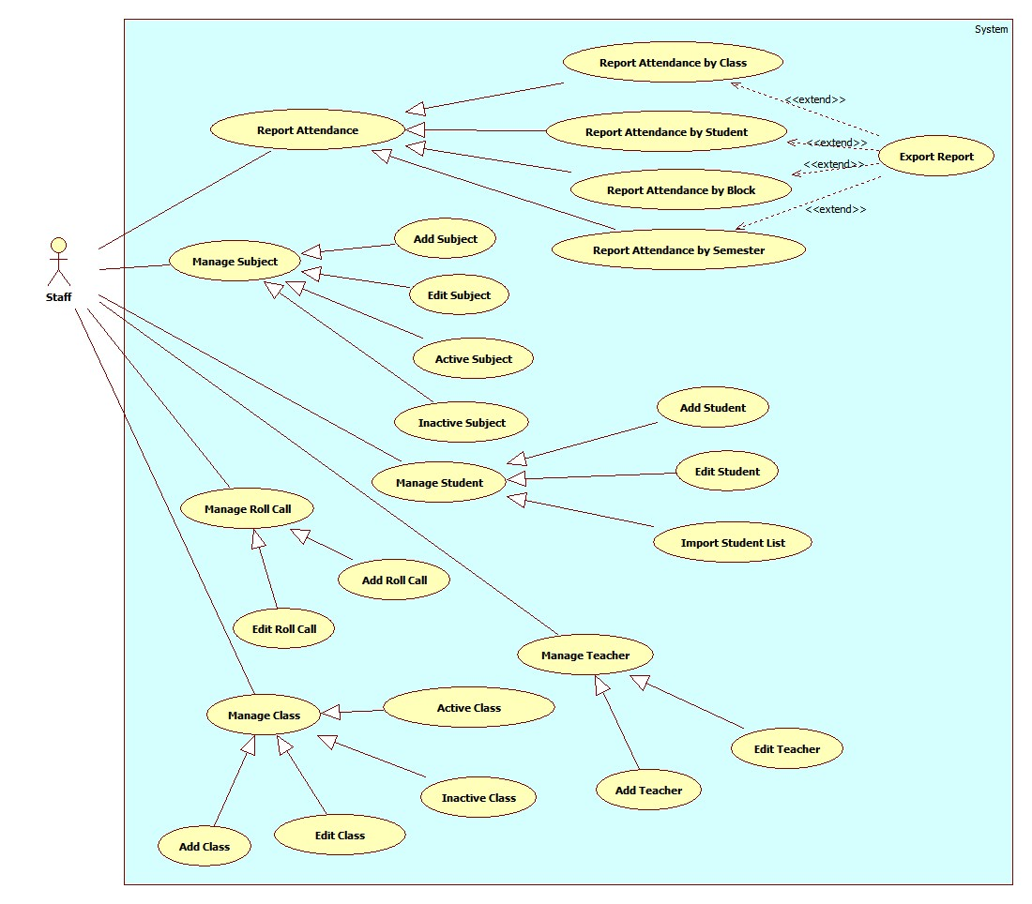

Figure 16: <Staff> Overview Use Case

##### <Staff>Add Roll Call

Use Case Diagram

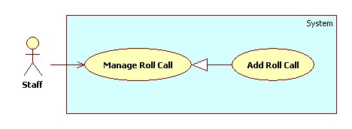

Figure 17: <Staff>Add Roll Call

Use Case Specification

|  |  |  |  |
| --- | --- | --- | --- |
| **USE CASE – SU001** | | | |
| **Use Case No.** | SU001 | **Use Case Version** | 2.0 |
| **Use Case Name** | Add Roll Call. | | |
| **Author** | Nguyen Quoc Huy. | | |
| **Date** | 19/09/2013 | **Priority** | Normal |
| **Actor:** Staff.  **Summary:**  Staff can create a new Roll Call.  **Goal:**  A new roll call includes: instructor, subject, class, date, time will be added to database.  **Triggers:**   * Staff can create new roll call for every block/semester * Staff must do these step to create new roll call:   + On Home page, click on link “Manage Roll Call” in menu sidebar and Manage Roll Call page will be showed.   + Then, choose “New Roll Call” tab.   + Then, choose the instructor, subject, class, student, date, time… for class.   + Click on button “Add”.   **Preconditions:**   * User must logged in the system with the role is staff.   **Post Conditions:**   * **Success**: A new roll call will be created. The roll call will be displayed on roll call list. * **Fail:** System will transfer to error page or still in current page.   **Main Success Scenario:**   |  |  |  | | --- | --- | --- | | Step | Actor Action | System Response | | 1 | Click “Manage Roll Call” in menu bar. | Redirect to Manage roll call page, include 2 tabs:   * Roll Call List * New Roll Call   Current Tab is Roll Call List, include table roll call list, for each roll call:   * No. : label * Instructor: label * Subject: label * Class: label * Date: label * Time: label * Show Student List: Button * Detail: Button * Status: label | | 2 | Click “New Roll Call” tab. | Display “New Roll Call” tab with :   * Instructor: Drop down list (value: all active instructor in database) * Subject: Drop down list (value: all active subject in database) * Class: Drop down list (value: all active class in database). * Button “Show Student List” * Date picker “Start date” and “End date” * Time: Drop down list(value: 7:00, 8:45, 10:30, 12:30, 14:15, 16:00) * Button “Add” | | 3 | Input roll call information, click “Add” button. | Add new roll call to database. Redirect Roll call list tab.  [Exception 1, 2, 3, 4] |   **Alternative Scenario:** N/A  **Exceptions:**   |  |  |  | | --- | --- | --- | | No | Actor Action | System Response | | 1 | The teacher already has different class at selected time. | Show error message “The teacher has a class at XX:XX, choose different time”. | | 2 | Class and subject have different major. | Show error message “The class and subject should have same major”. | | 3 | The subject, which has 2 slots, must not have time start at 10:30 or 16:00. | Show error message “The subject, which has 2 slot, should have time start at 7:00/8:45/12:30 or 14:15 ” | | 4 | Select “End date” is smaller than “Start Date”. | Show error message “The end date must be bigger than start date” |   **Relationships:** Manage Roll Call.  **Business Rules:**   * Start date must be later than current date; end date must be later than start date. * The class and subject belong to the same major. * When staff select a class for roll call, all students in that class is assigned to the roll call. | | | |

Table 13: <Staff>Add Roll Call

##### <Staff>Edit Roll Call

Use Case Diagram

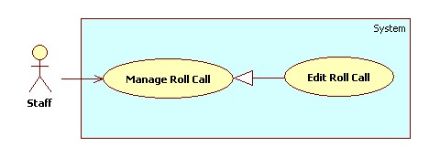

Figure 18: <Staff>Edit Roll Call

Use Case Specification

|  |  |  |  |
| --- | --- | --- | --- |
| **USE CASE – SU002** | | | |
| **Use Case No.** | SU002 | **Use Case Version** | 2.0 |
| **Use Case Name** | Edit Roll Call. | | |
| **Author** | Nguyen Quoc Huy. | | |
| **Date** | 19/09/2013 | **Priority** | Normal |
| **Actor:** Staff.  **Summary:**  Staff can use this case to edit a roll call.  **Goal:**  Update new information roll call includes: instructor, subject, class, date, time…  **Triggers:**   * Staff can update new information for roll call to database. * Staff must do these step to edit roll call: * In Home Page, click on link “Manage roll call”. * Click on button “Detail” in row, which staff wants to edit. * In “Roll call detail” pop-up window, edit information. * Click on button “Update”.   **Preconditions:**   * User must logged in the system with the role is staff.   **Post Conditions:**   * **Success**: A roll call will be updated. The system will transfer to roll call list page. * **Fail:** System will transfer to error page or still in current page.   **Main Success Scenario:**   |  |  |  | | --- | --- | --- | | Step | Actor Action | System Response | | 1 | Click “Manage Roll call” in menu bar. | Redirect to Manage roll call page, include 2 tabs:   * Roll Call List * New Roll Call   Current Tab is Roll Call List, include table roll call list, for each roll call:   * No. : label * Instructor: label * Subject: label * Class: label * Date: label * Time: label * Show Student List: Button * Detail: Button * Status: label | | 2 | Click button “Detail” in row, which staff wants to edit. | The system will show “Roll call detail” pop-up:   * Instructor: Drop down list (value of instructor list) * Subject: Drop down list (value of subject list) * Class: Drop down list (value of Class list) * Button “Show” * Date picker “Start date” and “End date” * Time: Drop down list(value: 7:00, 8:45, 11:00, 12:30, 14:15, 16:00) * Button “Update” * Button “Cancel” | | 3 | Edit Subject information, click “Update” button. | The system will update roll call to database. The system transfer to roll call list page.  [Exception 1, 2, 3] |   **Alternative Scenario:** N/A  **Exceptions:**   |  |  |  | | --- | --- | --- | | No | Actor Action | System Response | | 1 | The teacher teaches different class at time. | Display “The teacher should teach classes in different time”. | | 2 | Class and subject have different major. | Display “The class and subject should have same major”. | | 3 | The subject, which has 2 slots, must not have time start at 11:00 or 16:00. | Display “The subject, which has 2 slot, should have time start at 7:00/8:45/12:30 or 14:15 ” | | 4 | Select “End date” is smaller than “Start Date”. | Show error message “The end date must be bigger than start date” |   **Relationships:** Manage Roll Call.  **Business Rules:**   * In pop-up window, the value of instructor, subject, class, student list, date, time will be auto set by subject was chosen. * If the roll call status is “Created”, the staff can edit all roll call info. * If the roll call status is “Active”, the staff can only change the teacher of roll call. * If the roll call status is “Inactive”, the staff can edit anything. | | | |

Table 14: <Staff>Edit Roll Call

##### <Staff> Add Subject

Use Case Diagram

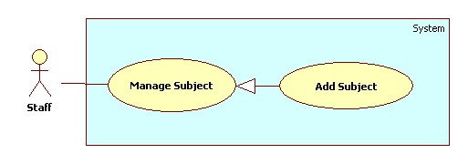

Figure 19: <Staff> Add Subject

Use Case Specification

|  |  |  |  |
| --- | --- | --- | --- |
| **USE CASE – SU003** | | | |
| **Use Case No.** | SU003 | **Use Case Version** | 2.0 |
| **Use Case Name** | Add Subject. | | |
| **Author** | Nguyen Quoc Huy. | | |
| **Date** | 19/09/2013 | **Priority** | Normal |
| **Actor:** Staff.  **Summary:**  Staff can create a new Subject.  **Goal:**  A new Subject include: major, name, slot will be added to database.  **Triggers:**   * Staff can create new subject with all information: name, major , slot … * Staff must do these step to create new subject:   + On Home page, click on link “Manage subject” in menu sidebar and Manage subject page will be showed.   + Then, choose “New subject” tab.   + Then, choose the major, input name, block for subject.   + Click on button “Add”.   **Preconditions:**   * User must logged in the system with the role is staff.   **Post Conditions:**   * **Success**: A new Subject will be created. The Subject will be displayed on Subject list. * **Fail:** System will transfer to error page or still in current page.   **Main Success Scenario:**   |  |  |  | | --- | --- | --- | | Step | Actor Action | System Response | | 1 | Click “Manage Subject” in menu bar. | Redirect to Manage Subject Page, include 2 tabs:   * Subject List * New Subject   Currnt Tab is Subject List. its include table subject ,for each row:   * No. : label * Major: label * Name: label * Slot (/day): label * Detail: button * Active/Inactive: button | | 2 | Click “New Subject” tab. | Display “New Subject” tab with :   * Major: Multiple chosen (value: Software Engineering, Financial Banking, Business Analysis) * Name: textbox (min length:1, max length: 30, required). * Slot (/day): drop down list (value: 1, 2). | | 3 | Input Subject information, click “Add” button. | Create new Subject to database. Redirect Subject list tab.  [Exception 1] |   **Alternative Scenario:** N/A  **Exceptions:**   |  |  |  | | --- | --- | --- | | Step | Actor Action | System Response | | 1 | Name’s length is not in range [1,30] | Display “Name’s length must be from 1 to 30 words”. |   **Relationships:** Manage Subject.  **Business Rules:**N/A | | | |

Table 15: <Staff> Add Subject

##### <Staff> Edit Subject

Use Case Diagram

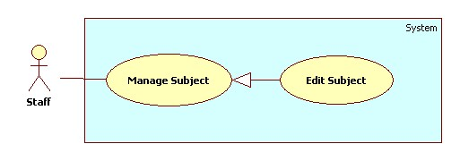

Figure 20: <Staff> Edit Subject

Use Case Specification

|  |  |  |  |
| --- | --- | --- | --- |
| **USE CASE – SU004** | | | |
| **Use Case No.** | SU004 | **Use Case Version** | 2.0 |
| **Use Case Name** | Edit Subject. | | |
| **Author** | Nguyen Quoc Huy. | | |
| **Date** | 19/09/2013 | **Priority** | Normal |
| **Actor:**Staff.  **Summary:**  Staff can use this case to edit a Subject.  **Goal:**  Updatenew information Subject includes: major, name, slot…  **Triggers:**   * User can update new information for subject to database. * Staff must do these step to Edit subject: * In Home Page, click on link “Manage subject”. * Click on button “Detail” in row, which staff wants to edit. * In “Subject detail” pop-up window, edit information. * Click on button “Update”.   **Preconditions:**   * User must logged in the system with the role is staff.   **Post Conditions:**   * **Success**: A Subject will be updated. The system will transfer to Subject list page. * **Fail:** System will transfer to error page or still in current page.   **Main Success Scenario:**   |  |  |  | | --- | --- | --- | | Step | Actor Action | System Response | | 1 | Click “Manage Subject” in menu bar. | Redirect to Manage Subject Page, include 2 tabs:   * Subject List * New Subject   Currnt Tab is Subject List. its include table subject ,for each row:   * No. : label * Major: label * Name: label * Slot (/day): label * Detail: button * Active/Inactive: button | | 2 | Click button “Detail” in row, which staff wants to edit. | The system will show “Subject detail” pop-up:   * Major: Drop down list (value: Software Engineering, Financial Banking, Business Analysis ) * Name: textbox (min length: 1 max length: 30, required). * Slot (/day): drop down list (value: 1, 2). | | 3 | Edit Subject information, click “Update” button. | The system will update Subject to database. The system transfer to Subject list page.  [Exception 1] |   **Alternative Scenario:** N/A  **Exceptions:**   |  |  |  | | --- | --- | --- | | No | Actor Action | System Response | | 1 | Name’s length is not in range [1,30] | Display “Name is invalid”. |   **Relationships:** Manage Subject.  **Business Rules:**   * In pop-up win down, the value of major, name, slot will be auto set by subject was chosen. | | | |

Table 16: <Staff> Edit Subject

##### <Staff> Active Subject

Use Case Diagram

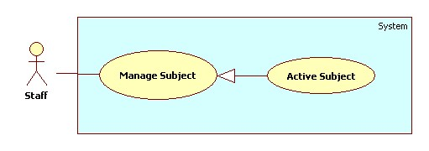

Figure 21: <Staff> Active Subject

Use Case Specification

|  |  |  |  |
| --- | --- | --- | --- |
| **USE CASE – SU005** | | | |
| **Use Case No.** | SU005 | **Use Case Version** | 2.0 |
| **Use Case Name** | Active Subject. | | |
| **Author** | Nguyen Quoc Huy. | | |
| **Date** | 19/09/2013 | **Priority** | Normal |
| **Actor:** Staff.  **Summary:**  Staff can use this case to active subject.  **Goal:**  Active a subject for new block.  **Triggers:**   * Staff can active a subject have exit. * Staff must do these step to Active subject: * In Home Page, click on link “Manage subject”. * Click on button “Inactive” in row, which staff wants to edit. * The system will show a message box confirm. * Click on button “Yes”.   **Preconditions:**   * User must logged in the system with the role is staff.   **Post Conditions:**   * **Success**: A Subject will be active. The system will still in current manage subject page. * **Fail:** System will transfer to error page or still in current page.   **Main Success Scenario:**   |  |  |  | | --- | --- | --- | | Step | Actor Action | System Response | | 1 | Click “Manage Subject” in menu bar. | Redirect to Manage Subject Page, include 2 tabs:   * Subject List * New Subject   Currnt Tab is Subject List. its include table subject ,for each row:   * No. : label * Major: label * Name: label * Slot (/day): label * Detail: button * Active/Inactive: button | | 2 | Click button “Inactive” in row, which staff wants to edit. | The system will show confirm message box:   * Text: “Do you want to active this object?” * Button “Yes” * Button “No” | | 3 | Click on button “Yes”  [Alternative 1] | The system will change status subject to active and still in current page. |   **Alternative Scenario:**   |  |  |  | | --- | --- | --- | | Step | Actor Action | System Response | | 1 | In confirm message box, staff click on button “No” | The system will still in current page with no value is changed. |   **Exceptions:** N/A  **Relationships:** Manage Subject.  **Business Rules:**   * The button active has color blue and button inactive has color orange. | | | |

Table 17: <Staff> Active Subject

##### <Staff> Inactive Subject

Use Case Diagram

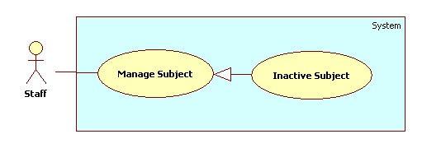

Figure 22: <Staff> Inactive Subject

Use Case Specification

|  |  |  |  |
| --- | --- | --- | --- |
| **USE CASE – SU006** | | | |
| **Use Case No.** | SU006 | **Use Case Version** | 2.0 |
| **Use Case Name** | Inactive Subject. | | |
| **Author** | Nguyen Quoc Huy. | | |
| **Date** | 19/09/2013 | **Priority** | Normal |
| **Actor:** Staff.  **Summary:**  Staff can use this case to inactive subject.  **Goal:**  Inactive a subject.  **Triggers:**   * Staff can inactive a subject have exit. * Staff must do these step to Inactive subject: * In Home Page, click on link “Manage subject”. * Click on button “Active” in row, which staff wants to edit. * The system will show a message box confirm. * Click on button “Yes”.   **Preconditions:**   * User must logged in the system with the role is staff.   **Post Conditions:**   * **Success**: A Subject will be inactive. The system will still in current manage subject page. * **Fail:** System will transfer to error page or still in current page.   **Main Success Scenario:**   |  |  |  | | --- | --- | --- | | Step | Actor Action | System Response | | 1 | Click “Manage Subject” in menu bar. | Redirect to Manage Subject Page, include 2 tabs:   * Subject List * New Subject   Currnt Tab is Subject List. its include table subject ,for each row:   * No. : label * Major: label * Name: label * Slot (/day): label * Detail: button * Active/Inactive: button | | 2 | Click button “Active” in row, which staff wants to edit. | The system will show confirm message box:   * Text: “Do you want to inactive this object?” * Button “Yes”. * Button “No”. | | 3 | Click on button “Yes”  [Alternative 1] | The system will change status subject to inactive and still in current page. |   **Alternative Scenario:**   |  |  |  | | --- | --- | --- | | Step | Actor Action | System Response | | 1 | In confirm message box, staff click on button “No” | The system will still in current page with no value is changed. |   **Exceptions:** N/A  **Relationships:** Manage Subject.  **Business Rules:**   * The button active has color blue and button inactive has color orange. | | | |

Table 18: <Staff> Inactive Subject

##### <Staff>Add Student

Use Case Diagram

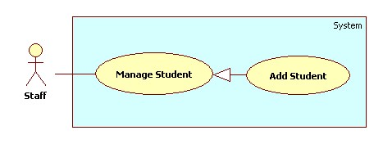

Figure 23: <Staff> Add Student

Use Case Specification

|  |  |  |  |
| --- | --- | --- | --- |
| **USE CASE – SU007** | | | |
| **Use Case No.** | SU007 | **Use Case Version** | 2.0 |
| **Use Case Name** | Add Student. | | |
| **Author** | Nguyen Quoc Huy. | | |
| **Date** | 19/09/2013 | **Priority** | Normal |
| **Actor:** Staff.  **Summary:**  Staff can create a new student.  **Goal:**  A new student include: name, email, student id, birthday, citizen id, address will be added to database.  **Triggers:**   * Staff can create new student with all information: name, email, student id, birthday, citizen id, address... * Staff must do these step to create new student:   + On Home page, click on link “Manage student” in menu sidebar and Manage student page will be showed.   + Then, choose “New student” tab.   + Then, choose the class, input name, id, email, citizen id, address for student.   + Click on button “Add”.   **Preconditions:**   * User must logged in the system with the role is staff.   **Post Conditions:**   * **Success**: A new student will be created. The student will be displayed on student list. * **Fail:** System will transfer to error page or still in current page.   **Main Success Scenario:**   |  |  |  | | --- | --- | --- | | Step | Actor Action | System Response | | 1 | Click “Manage Student” in menu bar. | Redirect to Manage Student Page, include 2 tabs:   * Student List * New Student * Import Student List   Current Tab is Student List, its include table student , for each row:   * No: label * Name: label * Current Classes: label * Email: label * Student ID: label * Detail: button * Active/Inactive: button | | 2 | Click “New Student” tab. | Display “New Student” tab with :   * Name: textbox (min length: 1 max length: 30, required). * Student ID: textbox (min length: 1 max length: 30, required). * Birthday: date picker (value: current date.) * Address: textbox (min length: 1 max length: 50, required). * Email: textbox (match regular expression:   ^([\w\.])+@([\w])+\.(\w){2,6}(\.([\w]){2,4})*$  , required).   * Citizen ID: (match regular expression:^\d{8}$   , required).   * Button “Add” * Button “Cancel” | | 3 | Input Student information, click “Add” button. | Create new student to database. Redirect student list tab.  [Exception 1,2,3,4] |   **Alternative Scenario:**   |  |  |  | | --- | --- | --- | | Step | Actor Action | System Response | | 1 | Click “Cancel” button. | All control in “New Student” tab is cleared. |   **Exceptions:**   |  |  |  | | --- | --- | --- | | No | Actor Action | System Response | | 1 | Name’s length is not in range [1,30] | Display “Name is invalid”. | | 2 | Address’s length is not in range [1,50] | Display “Address is invalid”. | | 3 | Student ID’s length is not in range [1,30] | Display “Student ID is invalid”. | | 4 | Email is not matched regular expression. | Display “Invalid email address”. |   **Relationships:** Manage Student.  **Business Rules:** N/A | | | |

Table 19: <Staff> Add Student

##### <Staff>Edit Student

Use Case Diagram

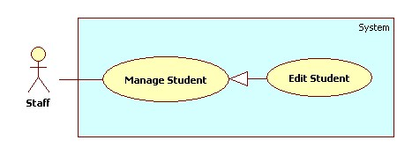

Figure 24: <Staff> Edit Student

Use Case Specification

|  |  |  |  |
| --- | --- | --- | --- |
| **USE CASE – SU008** | | | |
| **Use Case No.** | SU008 | **Use Case Version** | 2.0 |
| **Use Case Name** | Edit Student. | | |
| **Author** | Nguyen Quoc Huy. | | |
| **Date** | 19/09/2013 | **Priority** | Normal |
| **Actor:** Staff.  **Summary:**  Staff can use this case to edit a student.  **Goal:**  Update new information student includes: name, birthday, citizen ID, email…  **Triggers:**   * Staff can update new information for student to database. * Staff must do these step to edit student: * In Home Page, click on link “Manage Student”. * Click on button “Detail” in row, which staff wants to edit. * In “Student detail” pop-up window, edit information. * Click on button “Update”.   **Preconditions:**   * User must logged in the system with the role is staff.   **Post Conditions:**   * **Success**: A student will be updated. The system will transfer to student list page. * **Fail:** System will transfer to error page or still in current page.   **Main Success Scenario:**   |  |  |  | | --- | --- | --- | | Step | Actor Action | System Response | | 1 | Click “Manage Student” in menu bar. | Redirect to Manage Student Page, include 2 tabs:   * Student List * New Student * Import Student List   Current Tab is Student List, its include table student , for each row:   * No: label * Name: label * Current Classes: label * Email: label * Student ID: label * Detail: button * Active/Inactive: button | | 2 | Click button “Detail” in row, which staff wants to edit. | The system will show “Student Detail” pop-up:   * Name: textbox (min length: 1 max length: 30, required). * Student ID: textbox (min length: 1 max length: 30, required, disabled). * Birthday: date picker (value: current date.) * Address: textbox (min length: 1 max length: 50, required). * Email: textbox (match regular expression:   ^([\w\.])+@([\w])+\.(\w){2,6}(\.([\w]){2,4})*$  , required).   * Citizen ID: (match regular expression:^\d{8}$   , required).   * Update: button * Cancel: button | | 3 | Edit student information, click “Update” button.  [Alternative 1] | The system will update student to database. The system transfer to student list page.  [Exception 1,2,3,4] |   **Alternative Scenario:**   |  |  |  | | --- | --- | --- | | Step | Actor Action | System Response | | 1 | Click “Cancel” button. | The pop-up is closed. |   **Exceptions:**   |  |  |  | | --- | --- | --- | | No | Actor Action | System Response | | 1 | Name’s length is not in range [1,30] | Display “Name is invalid”. | | 2 | Address’s length is not in range [1,50] | Display “Address is invalid”. | | 3 | Student ID’s length is not in range [1,30] | Display “Student ID is invalid”. | | 4 | Email is not matched regular expression. | Display “Invalid email address”. |   **Relationships:** Manage Student.  **Business Rules:**   * In pop-up window, the value of name, current class, address, citizen id, and birthday will be auto set by student was chosen. | | | |

Table 20: <Staff> Edit Student

##### <Staff>Import Student List

Use Case Diagram

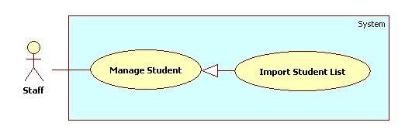

Figure 25: <Staff> Import Student List

Use Case Specification

|  |  |  |  |
| --- | --- | --- | --- |
| **USE CASE – SU009** | | | |
| **Use Case No.** | SU009 | **Use Case Version** | 2.0 |
| **Use Case Name** | Import student list | | |
| **Author** | Nguyen Quoc Huy. | | |
| **Date** | 19/09/2013 | **Priority** | Normal |
| **Actor:** Staff.  **Summary:**  Staff can use this case to import student list.  **Goal:**  Create multiple student by import from excel file.  **Triggers:**   * User can import an excel file student list. * Staff must do these step to import student list: * In Home Page, click on link “Manage Student”. * Click on tab “Import Student List” * Click on button “Import” * Then, choose the excel file in browser dialog.   **Preconditions:**   * User must logged in the system with the role is staff.   **Post Conditions:**   * **Success**: Student list will be added to database. * **Fail:** System will transfer to error page or still in current page.   **Main Success Scenario:**   |  |  |  | | --- | --- | --- | | Step | Actor Action | System Response | | 1 | Click “Manage Student” in menu bar. | Redirect to Manage Student Page, include 2 tabs:   * Student List * New Student * Import Student List   Current Tab is Student List, its include table student ,for each row:   * No: label * Name: label * Current Classes: label * Email: label * Student ID: label * Detail: button * Active/Inactive: button | Click “Manage Student” in menu bar. | Redirect to Manage Student Page, include 2 tabs:   * Student List * New Student   Student List is tab default, its include table student ,for each row:   * “No.” * “Name”. * “Current Classes”. * “Email”. * “Student ID”. * Button “Detail” * Button “Active/Inactive”. | | 2 | Click “Import Student List” tab | Display “Import Student List” tab with :   * Import file: File upload control. * Button “Import” | | 3 | Click on textbox Import file, choose file. Click “Ok” | The system will get path file and show on text box (only allow excel file.) | | 4 | Click on button “Import” | Import student list to database and show a message box:   * Text: “Import is successful!   There are [number of student in file] student and [number of class in file] class were imported to database”   * Button “Ok”.   [Exception 1] |   **Alternative Scenario:** N/A  **Exceptions:**   |  |  |  | | --- | --- | --- | | No | Actor Action | System Response | | 1 | Import file get error. | Show error message, the sheet, line, row where error occur. |   **Relationships:** Manage Student.  **Business Rules:**   * The input excel file must follow a student list excel template. | | | |

Table 21: <Staff> Import Student List

##### <Staff>Add Instructor

Use Case Diagram

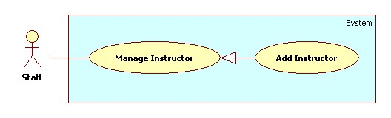

Figure 26: <Staff>Add Instructor

Use Case Specification

|  |  |  |  |
| --- | --- | --- | --- |
| **USE CASE – SU010** | | | |
| **Use Case No.** | SU010 | **Use Case Version** | 2.0 |
| **Use Case Name** | Add instructor. | | |
| **Author** | Nguyen Quoc Huy. | | |
| **Date** | 19/09/2013 | **Priority** | Normal |
| **Actor:** Staff.  **Summary:**  Staff can create a new instructor.  **Goal:**  A new instructor include: name, current subject, current class, and phone number will be added to database.  **Triggers:**   * Staff can create new instructor with all information: name, current subject , current class, phone number … * Staff must do these step to create new instructor:   + On Home page, click on link “Manage Instructor” in menu sidebar and Manage Instructor page will be showed.   + Then, choose “New Instructor” tab.   + Then, choose the Classes, subject, input name, phone number for instructor.   + Click on button “Add”.   **Preconditions:**   * User must logged in the system with the role is staff.   **Post Conditions:**   * **Success**: A new instructor will be created. The instructor will be displayed on instructor list. * **Fail:** System will transfer to error page or still in current page.   **Main Success Scenario:**   |  |  |  | | --- | --- | --- | | Step | Actor Action | System Response | | 1 | Click “Manage Instructor” in menu bar. | Redirect to Manage instructor page, include 2 tabs:   * Instructor List * New Instructor   Current Tab is Instructor List, include table instructor list, for each instructor:   * No: label * Name: label * Teaching Subject: label * Teaching Class: label * Detail: button * Active/Inactive: button | | 2 | Click “New Instructor” tab. | Display “New Instructor” tab with :   * Instructor name: Text box (min length:1 max length:30, required) * Email: textbox (match regular expression:   ^([\w\.])+@([\w])+\.(\w){2,6}(\.([\w]){2,4})*$  , required).   * Phone number: text box (min length: 8, max length: 11, match regular expression: ^\s*\d+\s*$ ) | | 3 | Input instructor information, click “Add” button. | Create new instructor to database. Redirect instructor list tab.  [Exception 1, 2, 3] |   **Alternative Scenario:** N/A  **Exceptions:**   |  |  |  | | --- | --- | --- | | No | Actor Action | System Response | | 1 | Name’s length is not in range [1,30] | Display “Name is invalid”. | | 2 | Email not matched regular expresion | Display “Email is invalid”. | | 3 | Phone number is not matched regular expresion. | Display “Phone number is invalid”. |   **Relationships:** Manage instructor.  **Business Rules:** N/A | | | |

Table 22: <Staff>Add Instructor

##### <Staff>Edit Instructor

Use Case Diagram

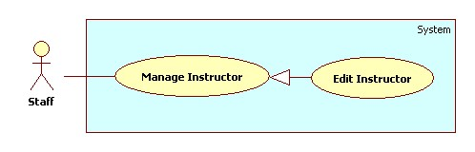

Figure 27: <Staff>Edit Instructor

Use Case Specification

|  |  |  |  |
| --- | --- | --- | --- |
| **USE CASE – SU011** | | | |
| **Use Case No.** | SU011 | **Use Case Version** | 2.0 |
| **Use Case Name** | Edit instructor. | | |
| **Author** | Nguyen Quoc Huy. | | |
| **Date** | 19/09/2013 | **Priority** | Normal |
| **Actor:** Staff.  **Summary:**  Staff can use this case to edit an instructor.  **Goal:**  Update new information instructor includes: name, current subjects, current classes, phone…  **Triggers:**   * Staff can update new information for instructor to database. * Staff must do these step to edit instructor: * In Home Page, click on link “Manage Instructor”. * Click on button “Detail” in row, which staff wants to edit. * In “Instructor detail” pop-up window, edit information. * Click on button “Update”.   **Preconditions:**   * User must logged in the system with the role is staff.   **Post Conditions:**   * **Success**: An instructor will be updated. The system will transfer to instructor list page. * **Fail:** System will transfer to error page or still in current page.   **Main Success Scenario:**   |  |  |  | | --- | --- | --- | | Step | Actor Action | System Response | | 1 | Click “Manage Instructor” in menu bar. | Redirect to Manage instructor page, include 2 tabs:   * Instructor List * New Instructor   Current Tab is Instructor List, include table instructor list, for each instructor:   * No: label * Name: label * Teaching Subject: label * Teaching Class: label * Detail: button * Active/Inactive: button | | 2 | Click button “Detail” in row, which staff wants to edit. | The system will show “Instructor detail” pop-up:   * Instructor name: Text box (min length:1 max length:30, required) * Email: textbox (match regular expression:   ^([\w\.])+@([\w])+\.(\w){2,6}(\.([\w]){2,4})*$  , required).   * Phone number: text box (min length: 8, max length: 11, match regular expression: ^\s*\d+\s*$ ) * Update: button * Cancel: button | | 3 | Edit instructor information, click “Update” button.  [Alternative 1] | The system will update instructor to database. The system transfer to instructor list page.  [Exception 1, 2] |   **Alternative Scenario:**   |  |  |  | | --- | --- | --- | | Step | Actor Action | System Response | | 1 | Click “Cancel” button. | The pop-up is closed. |   **Exceptions:**   |  |  |  | | --- | --- | --- | | No | Actor Action | System Response | | 1 | Name’s length is not in range [1,30] | Display “Name is invalid”. | | 2 | Phone number is not matched regular exception. | Display “Phone number is invalid”. |   **Relationships:** Manage Instructor.  **Business Rules:**   * In pop-up window, the value of name, current class, current subject, phone number will be auto set by instructor was chosen. | | | |

Table 23: <Staff> Edit Instructor

##### <Staff>Add Class

Use Case Diagram

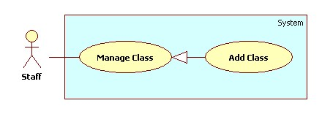

Figure 28: <Staff> Add Class

Use Case Specification

|  |  |  |  |
| --- | --- | --- | --- |
| **USE CASE – SU012** | | | |
| **Use Case No.** | SU012 | **Use Case Version** | 2.0 |
| **Use Case Name** | Add Class. | | |
| **Author** | Nguyen Quoc Huy. | | |
| **Date** | 19/09/2013 | **Priority** | Normal |
| **Actor:** Staff.  **Summary:**  Staff can create a new Class.  **Goal:**  A new class includes: major, name will be added to database.  **Triggers:**   * Staff can create new class with for every block/semester/year… * Staff must do these step to create new class:   + On Home page, click on link “Manage Class” in menu sidebar and Manage subject page will be showed.   + Then, choose “New Class” tab.   + Then, choose the major, input name for class.   + Click on button “Add”.   **Preconditions:**   * User must logged in the system with the role is staff.   **Post Conditions:**   * **Success**: A new class will be created. The class will be displayed on Class list. * **Fail:** System will transfer to error page or still in current page.   **Main Success Scenario:**   |  |  |  | | --- | --- | --- | | Step | Actor Action | System Response | | 1 | Click “Manage Class” in menu bar. | Redirect to Manage Class Page, include 2 tabs:   * Class List * New Class   Current Tab is Class List, include table class list, for each class:   * No: label * Major: label * Name: label * Show Student List: button * Detail: button * Active/Inactive: button | | 2 | Click “New Class” tab. | Display “New Class” tab with :   * Major: Drop down list (value: Software Engineering, Financial Banking, Business Analysis ) * Name: textbox (min length: 1 max length: 30, required). * Add: button * Cancel: button | | 3 | Input class information, click “Add” button. | Create new class to database. Redirect Class list tab.  [Exception 1, 2] |   **Alternative Scenario:**   |  |  |  | | --- | --- | --- | | Step | Actor Action | System Response | | 1 | Click “Cancel” button. | The input form is reseted. |   **Exceptions:**   |  |  |  | | --- | --- | --- | | Step | Actor Action | System Response | | 1 | Name’s length is not in range [1,30] | Display “Name is invalid”. | | 2 | The name class has existed. | Display “The class has existed”. |   **Relationships:** Manage Class.  **Business Rules:** N/A | | | |

Table 24: <Staff> Add Class

##### <Staff>Edit Class

Use Case Diagram

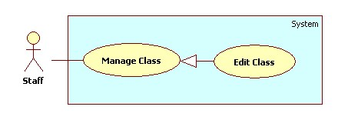

Figure 29: <Staff> Edit Class

Use Case Specification

|  |  |  |  |
| --- | --- | --- | --- |
| **USE CASE – SU013** | | | |
| **Use Case No.** | SU013 | **Use Case Version** | 2.0 |
| **Use Case Name** | Edit Class. | | |
| **Author** | Nguyen Quoc Huy. | | |
| **Date** | 19/09/2013 | **Priority** | Normal |
| **Actor:** Staff.  **Summary:**  Staff can use this case to edit a class.  **Goal:**  Update new information class includes: major, name …  **Triggers:**   * User can update new information for class to database. * Staff must do these step to Edit class: * In Home Page, click on link “Manage Class”. * Click on button “Detail” in row, which staff wants to edit. * In “Class detail” pop-up window, edit information. * Click on button “Update”.   **Preconditions:**   * User must logged in the system with the role is staff.   **Post Conditions:**   * **Success**: A class will be updated. The system will transfer to class list page. * **Fail:** System will transfer to error page or still in current page.   **Main Success Scenario:**   |  |  |  | | --- | --- | --- | | Step | Actor Action | System Response | | 1 | Click “Manage Class” in menu bar. | Redirect to Manage Class Page, include 2 tabs:   * Class List * New Class   Current Tab is Class List, include table class list, for each class:   * No: label * Major: label * Name: label * Show Student List: button * Detail: button * Active/Inactive: button | | 2 | Click button “Detail” in row, which staff wants to edit. | The system will show “Class detail” pop-up:   * Major: Drop down list (value: Software Engineering, Financial Banking, Business Analysis ) * Name: textbox (min length: 1 max length: 30, required). * Table: Student List of class. * Update: button * Cancel: button | | 3 | Edit Class information, click “Update” button.  [Alternative 1] | The system will update class to database. The system transfer to class list page. |   **Alternative Scenario:**   |  |  |  | | --- | --- | --- | | Step | Actor Action | System Response | | 1 | Click “Cancel” button. | The pop-up is closed. |   **Exceptions:**   |  |  |  | | --- | --- | --- | | No | Actor Action | System Response | | 1 | Name’s length is not in range [1,30] | Display “Name is invalid”. |   **Relationships:** Manage Class.  **Business Rules:**   * In pop-up win down, the value of major, name will be auto set by class was chosen. | | | |

Table 25 <Staff> Edit Class

##### <Staff> Report Attendance by Class

Use Case Diagram

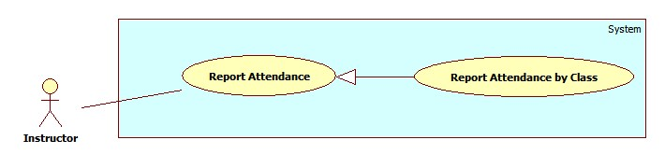

Figure 30: <Staff> Report Attendance by Class

Use Case Specification

|  |  |  |  |
| --- | --- | --- | --- |
| **USE CASE – SU014** | | | |
| **Use Case No.** | SU014 | **Use Case Version** | 2.0 |
| **Use Case Name** | Report Attendance by Class | | |
| **Author** | Nguyen Quoc Huy. | | |
| **Date** | 19/09/2013 | **Priority** | Normal |
| **Actor:** Staff.  **Summary:**  This use case allows staff report attendance of all students by class.  **Goal:**  Staff can report attendance of class.  **Triggers:**   * Staff can report information of class: subject, student, attendance… * Staff must do these step to view report result:   + On Home page, click on link “Report” in menu bar and Report page will be showed.   + Then, in select box “Report by” choose type: Class.   + Then, in drop down list “Name” chose the class name.   + Click on button “Statistic”.   **Preconditions:**   * User must logged in the system with the role is staff.   **Post Conditions:**   * **Success**: A report attendance by class will be showed on screen. * **Fail:** The system will transfer to error page or still in current page.   **Main Success Scenario:**   |  |  |  | | --- | --- | --- | | Step | Actor Action | System Response | | 1 | Click “Report” link in menu bar. | Redirect to Report Page, include 4 part:   * Drop down list “Report by” (value: Class, Student, Block, and Semester). * Drop down list “Name” (value: auto set based on drop down list Report by) * Button “Statistic” * Button “Export”. | | 2 | Choose “Class” in drop down list Report by. | System will auto set value based on type Class (just active class) for drop down list “Name”. | | 3 | Chose the class in drop down list “Name”. Click button “Statistic” | System will show result attendance by class on screen.  System still in current “Report” page. |   **Alternative Scenario:** N/A  **Exceptions:** N/A  **Relationships:** Manage Report Attendance.  **Business Rules:**   * System will show attendance result in chosen conditions. * Default value when manager clicks on tab “Report” is: Class. | | | |

Table 26: <Staff> Report Attendance by Class

##### <Staff> Report Attendance by Student

Use Case Diagram

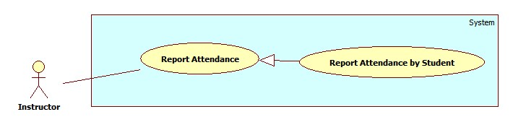

Figure 31: <Staff> Report Attendance by Student

Use Case Specification

|  |  |  |  |
| --- | --- | --- | --- |
| **USE CASE – SU015** | | | |
| **Use Case No.** | SU015 | **Use Case Version** | 2.0 |
| **Use Case Name** | Report Attendance by Student | | |
| **Author** | Nguyen Quoc Huy. | | |
| **Date** | 19/09/2013 | **Priority** | Normal |
| **Actor:** Staff.  **Summary:**  This use case allows staff report attendance of student.  **Goal:**  Staff can report attendance of student.  **Triggers:**   * Staff can report information of student: student name, class, subject, attendance… * Staff must do these step to view report result:   + On Home page, click on link “Report” in menu bar and Report page will be showed.   + Then, in drop down list “Report by” choose type: Student.   + Then, in drop down list “Name” choose the student name.   + Click on button “Statistic”.   **Preconditions:**   * User must logged in the system with the role is staff.   **Post Conditions:**   * **Success**: A report attendance by student will be showed on screen. * **Fail:** System will not return any value. Transfer to error page or still in current page.   **Main Success Scenario:**   |  |  |  | | --- | --- | --- | | Step | Actor Action | System Response | | 1 | Click “Report” link in menu bar. | Redirect to Report Page, include 4 part:   * Drop down list “Report by” (value: Class, Student, Block, and Semester). * Drop down list “Name” (value: auto set based on drop down list Report by) * Button “Statistic” * Button “Export”. | | 2 | Choose “Student” in drop down list Report by. | System will auto set value based on type Student (just active student) for drop down list “Name”. | | 3 | Chose the student in drop down list “Name”. Click button “Statistic”. | System will show result attendance by student on screen.  System still in current “Report” page. |   **Alternative Scenario:** N/A  **Exceptions:** N/A  **Relationships:** Manage Report Attendance.  **Business Rules:**   * System will show attendance result in chosen conditions. * Default value when manager clicks on tab “Report” is: Class. | | | |

Table 27: <Staff> Report Attendance by Student

##### <Staff> Report Attendance by Block

Use Case Diagram

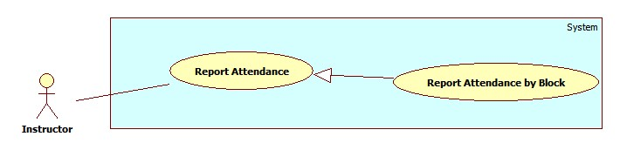

Figure 32: <Staff> Report Attendance by Block

Use Case Specification

|  |  |  |  |
| --- | --- | --- | --- |
| **USE CASE – SU016** | | | |
| **Use Case No.** | SU016 | **Use Case Version** | 2.0 |
| **Use Case Name** | Report Attendance by Block | | |
| **Author** | Nguyen Quoc Huy. | | |
| **Date** | 19/09/2013 | **Priority** | Normal |
| **Actor:** Staff.  **Summary:**  This use case allows staff report attendance all students by block.  **Goal:**  Staff can report attendance of student.  **Triggers:**   * Staff can report information of student: Block, class, subject, attendance… * Staff must do these step to view report result:   + On Home page, click on link “Report” in menu bar and Report page will be showed.   + Then, in drop down list “Report by” choose type: Block.   + Then, in drop down list “Name” choose the block.   + Click on button “Statistic”.   **Preconditions:**   * User must logged in the system with the role is staff.   **Post Conditions:**   * **Success**: A report attendance by block will be showed on screen. * **Fail:** System will not return any value. Transfer to error page or still in current page.   **Main Success Scenario:**   |  |  |  | | --- | --- | --- | | Step | Actor Action | System Response | | 1 | Click “Report” link in menu bar. | Redirect to Report Page, include 4 part:   * Drop down list “Report by” (value: Class, Student, Block, and Semester). * Drop down list “Name” (value: auto set based on drop down list Report by) * Button “Statistic” * Button “Export”. | | 2 | Choose “Block” in drop down list Report by. | System will auto set value based on type Block (just active block) for drop down list “Name”. | | 3 | Chose the Block in drop down list “Name”. Click button “Statistic”. | System will show result attendance by block on screen.  System still in current “Report” page. |   **Alternative Scenario:** N/A  **Exceptions:** N/A  **Relationships:** Manage Report Attendance.  **Business Rules:**   * System will show attendance result in chosen conditions. * Default value when manager clicks on tab “Report” is: Class. | | | |

Table 28: <Staff> Report Attendance by Block

##### <Staff> Report Attendance by Semester

Use Case Diagram

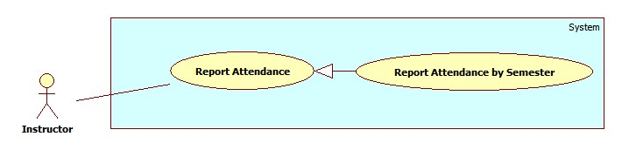

Figure 33: <Staff> Report Attendance by Semester

Use Case Specification

|  |  |  |  |
| --- | --- | --- | --- |
| **USE CASE – SU017** | | | |
| **Use Case No.** | SU017 | **Use Case Version** | 2.0 |
| **Use Case Name** | Report by Semester. | | |
| **Author** | Nguyen Quoc Huy. | | |
| **Date** | 19/09/2013 | **Priority** | Normal |
| **Actor:** Staff.  **Summary:**  This use case allows staff report attendance by semester.  **Goal:**  Staff can report attendance by semester.  **Triggers:**   * Staff can report information of student: Block, class, subject … * Staff must do these step to view report result:   + On Home page, click on link “Report” in menu bar and Report page will be showed.   + Then, in drop down list “Report by” choose type: Semester.   + Then, in drop down list “Name” choose the semester.   + Click on button “Statistic”.   **Preconditions:**   * User must logged in the system with the role is staff.   **Post Conditions:**   * **Success**: A report attendance by semester will be showed on screen. * **Fail:** System will not return any value. Transfer to error page or still in current page.   **Main Success Scenario:**   |  |  |  | | --- | --- | --- | | Step | Actor Action | System Response | | 1 | Click “Report” link in menu bar. | Redirect to Report Page, include 4 part:   * Drop down list “Report by” (value: Class, Student, Block, and Semester). * Drop down list “Name” (value: auto set based on drop down list Report by) * Button “Statistic” * Button “Export”. | | 2 | Choose “Semester” in drop down list Report by. | System will auto set value based on type Semester (just active semester) for drop down list “Name”. | | 3 | Chose the semester in drop down list “Name”. Click button “Statistic”. | System will show result attendance by semester on screen.  System still in current “Report” page. |   **Alternative Scenario:** N/A  **Exceptions:** N/A  **Relationships:** Manage Report Attendance.  **Business Rules:**   * System will show attendance result in chosen conditions. * Default value when manager clicks on tab “Report” is: Class. | | | |

Table 29: <Staff> Report Attendance by Semester

##### <Staff> Export Report

Use Case Diagram

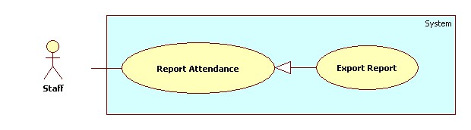

Figure 34: <Staff> Export Report

Use Case Specification

|  |  |  |  |
| --- | --- | --- | --- |
| **USE CASE – SU018** | | | |
| **Use Case No.** | SU018 | **Use Case Version** | 2.0 |
| **Use Case Name** | Export report. | | |
| **Author** | Nguyen Quoc Huy. | | |
| **Date** | 19/09/2013 | **Priority** | Normal |
| **Actor:** Staff.  **Summary:**  Staff uses this case to Export report.  **Goal:**  Allow staff to export report.  **Triggers:**   * Staff can export report. * On report page, click on button “Export” to export report.   **Preconditions:**   * User must logged in the system with the role is staff.   **Post Conditions:**   * **Success**: Staff can export report. The system still in current page. * **Fail:** N/A.   **Main Success Scenario:**   |  |  |  | | --- | --- | --- | | Step | Actor Action | System Response | | 1 | Click on “Export” to request export report on Report page | System will export report to file excel |   **Alternative Scenario:** N/A  **Exceptions:** N/A  **Relationships:** Manage Report Attendance.  **Business Rules:**   * Staff export report to file excel and attendance: class, block, student, semester … | | | |

#### < Instructor>Overview Use Case

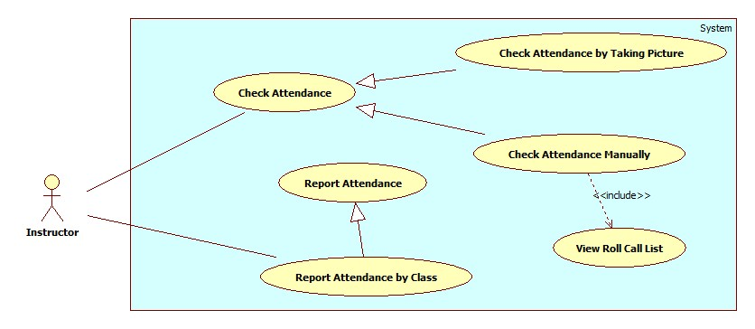

Figure 35: <Instructor> Overview Use Case

##### <Instructor> Capture and Show result attendance

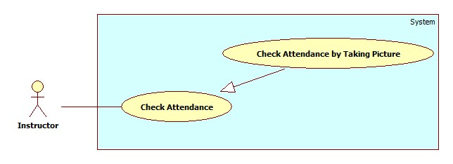

Figure 36: <Instructor> Capture and Show result attendance

|  |  |  |  |
| --- | --- | --- | --- |
| **USE CASE – IU001** | | | |
| **Use Case No.** | IU001 | **Use Case Version** | 2.0 |
| **Use Case Name** | Capture and Show result attendance | | |
| **Author** | Nguyen Thanh Binh | | |
| **Date** | 23/09/2013 | **Priority** | High |
| **Actor:** Instructor.  **Summary:**  Instructor uses this case to check attendance.  **Goal:**  Allow instructor capture image, send image to web service and check attendance.  **Triggers:**   * Instructor can use mobile to take picture. This picture will be used for attendance checking ... To check attendance using picture, instructor must do: * Instructor login application and click button “Take Attendance” in Roll Call page. System transfer to “Taking Attendance” Page. * On “Taking Attendance” page, Instructor capture image, then send image to web service for detected face of member. * Instructor receive result from Web service. Instructor view result and check attendance for members.   **Preconditions:**   * User must logged in the system with the role is Instructor * Instructor is assign to class   **Post Conditions:**   * **Success**: Instructor can check attendance for student. The attendance log will be stored. * **Fail:** System will alert error.   **Main Success Scenario:**   |  |  |  | | --- | --- | --- | | Step | Actor Action | System Response | | 1 | Instructor open mobile app.  Instructor type username, password, press “Login” to login into application. | System will show the Roll call page with information includes:   * Instructor name: label * No: label * Subject: label * Class name: label * Class Time: Calendar * Class date: Calendar   **Main menu:**   * Detail: Button (follow each course) * Take Attendance: Button | | 2 | Instructor click button “Take Attendance” to capture picture.  [Alternative 1] | System transfer to Taking Attendance page with:   * Camera screen view: Frame layout * Capture: Button | | 3 | Instructor look at screen and click “Capture” button to capture image and send image to web service. | System will save image on real time when instructor click button “Capture”.  Image is sent to web service.  Then, system create show a popup “Sending success” with button “OK”.  [Exception 1,2] | | 4 | Instructor click “OK” button to return to Course page. | System will notify result to Instructor.  Result contains the students detected from image.  [Exception 3, 4, 5] |   **Alternative Scenario:**   |  |  |  | | --- | --- | --- | | Step | Actor Action | System Response | | 1 | Instructor click button “Detail” to check attendance with use case “IU002”. | System will transfer to Roll Call Detail page. |   **Exceptions:**   |  |  |  | | --- | --- | --- | | Step | Actor Action | System Response | | 1 | Error with camera (No camera, can’t connect to camera) | System will show popup “Camera is not available”. | | 2 | Can’t send image to service | System will show a popup “Failed to connect server, please check you internet connection and try it again”. Instructor click “OK” button to retake an image. | | 3 | No respond from service | System will show popup “Request timeout. Please try again”. | | 4 | Only some student detected (<30% number of class students) | System will vibrate and notify “Only X student detect. You can take more picture, or check attendance manually (See Use Case IU002)”. | | 5 | Stranger detected | System will vibrate and notify “Stranger Detected”. |   **Relationships:** N/A  **Business Rules:**   * Image : min 1500px * 1000px max 3552px * 2000px or size smaller than 3mb; resolution 72dpi (recommend) * Cable: 3mb ~ 6mb, Wifi: 3mb ~ 6mb * The average time for attendance taking is 10 seconds. * In success case, the app will notify normally, without sound or vibration. In exception case, the notification is with sound and vibration. | | | |

Table 30: <Instructor> Check Attendance by Taking Picture

##### <Instructor> Check Attendance Manually

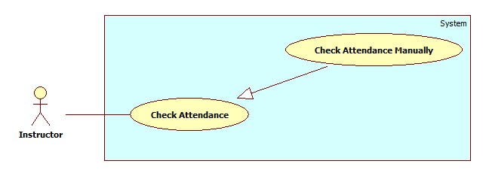

Figure 37: <Instructor> Check Attendance Manually

|  |  |  |  |
| --- | --- | --- | --- |
| **USE CASE – IU002** | | | |
| **Use Case No.** | IU002 | **Use Case Version** | 2.0 |
| **Use Case Name** | Check Attendance Manually | | |
| **Author** | Nguyen Thanh Binh | | |
| **Date** | 23/09/2013 | **Priority** | High |
| **Actor:** Instructor.  **Summary:**   * Instructor uses this case to check attendance manually.   **Goal:**   * Allow instructor check attendance again for some special reasons.   **Triggers:**   * Sometimes, the auto attendance checking is not accuracy, the instructor must check attendance manually. * To check attendance again manually, instructor must do: * Instructor login application and click button “Detail” in “Roll Call” page. System transfer to “Roll Call Detail” Page. * Instructor review all members and check attendance for member have special reason on this day or previous day.   **Preconditions:**   * User must logged in the system with the role is Instructor. * Instructor is assign to class.   **Post Conditions:**   * **Success**: Instructor can check attendance for member on this day or previous day. * **Fail:** System will alert error.   **Main Success Scenario:**   |  |  |  | | --- | --- | --- | | Step | Actor Action | System Response | | 1 | Instructor open mobile app.  Instructor type username, password, press “Login” to login into application. | System will show the Roll call page with information includes:   * Instructor name: label * No: label * Subject: label * Class name: label * Class Time: Calendar * Class date: Calendar   **Main menu:**   * Detail: Button (follow each course) * Take Attendance: Button | | 2 | Instructor click button “Detail” to view detail of that Subject.  [Alternative 1] | System will show Roll Call Detail:   * Roll call: label * Instructor Name: label * Class Name: label * Subject: label * Date & Time: Calendar * Student List: link show(No., Name, Code) * Attendance Log: * No: label * Date: Calendar * Present: Number * Log Detail: button | | 3 | Instructor click button “Log Detail” with correlative Date.  [Alternative 2] | System will show Log detail page on correlative with three tab:   * Roll Call info (Roll Call, Date, Subject, Class) * Log image * Attendance: * No: label * Student name: label * Present & Absent : Ratio button * Note: textbox * Present All & Absent All: Ration button * Submit Attendance: Button | | 4 | Click “Present” ratio button with correlative student.  [Alternative 3, 4, 5]  Write info on Note text box (recommend).  Click button “Submit Attendance” send request to check attendance for present member. | System will send request check attendance for present member to server.  System will show popup “Save changed!” with button “OK” | | 5 | Instructor click button “OK” redirect to Roll call page. |  |   **Alternative Scenario:**   |  |  |  | | --- | --- | --- | | Step | Actor Action | System Response | | 1 | Instructor click button “Take Attendance” to check attendance with Use case “IU001”. | System will transfer to Taking Attendance page. | | 2 | Instructor click “Student list” link. | System will show popup all student with correlative class and course. | | 3 | Instructor click “Absent” ratio button with correlative student. | System will set absent for correlative student. | | 4 | Instructor click “Absent” ratio button with correlative student. | System will set present for all student. | | 5 | Instructor click “Absent All” ratio button with correlative student. | System will set absent for all student. |   **Exceptions:**   |  |  |  | | --- | --- | --- | | Step | Actor Action | System Response | | 1 | Can’t connection to service | System will show a popup “Failed to connect server, please check you internet connection and try it again”. Instructor click “OK” button to transfer Roll Call page. | | 2 | No respond from service | System will show popup “Request timeout. Please try again”. |   **Relationships:** N/A  **Business Rules:**   * Instructor can check present member again for student have special reason. | | | |

Table 31: <Instructor> Check Attendance Manually

##### <Instructor> View Roll Call List

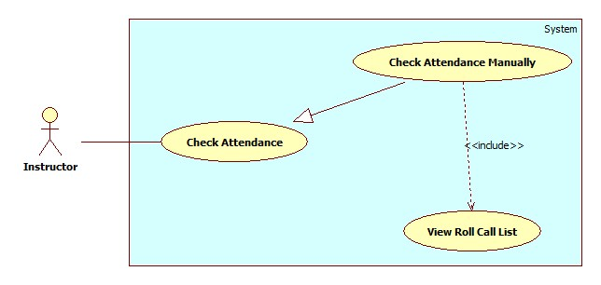

Figure 38: <Instructor> View Roll Call List

|  |  |  |  |
| --- | --- | --- | --- |
| **USE CASE – IU003** | | | |
| **Use Case No.** | IU003 | **Use Case Version** | 2.0 |
| **Use Case Name** | View Roll Call List | | |
| **Author** | Nguyen Thanh Binh | | |
| **Date** | 23/09/2013 | **Priority** | Normal |
| **Actor:** Instructor.  **Summary:**  Instructor uses this case to view all roll call list.  **Goal:**  Allow instructor view roll call list with current day or previous day to check attendance again for member have special reason.  **Triggers:**   * Instructor login application and click button “Report” in Course page. System transfer to “Roll Call” Page. * Instructor review all members with course, class and selected day.   **Preconditions:**   * User must logged in the system with the role is Instructor. * Instructor is assign to class.   **Post Conditions:**   * **Success**: Instructor can view list of members on current day or previous day with selected course, class. * **Fail:** System will transfer to error page or still in current page.   **Main Success Scenario:**   |  |  |  | | --- | --- | --- | | Step | Actor Action | System Response | | 1 | Instructor open mobile app.  Instructor type username, password, press “Login” to login into application. | System will show the Roll call page with information includes:   * Instructor name: label * No: label * Subject: label * Class name: label * Class Time: Calendar * Class date: Calendar   **Main menu:**   * Detail: Button (follow each course) * Take Attendance: Button | | 2 | Instructor click button “Detail” to view detail of that Subject.  [Alternative 1] | System will show Roll Call Detail:   * Roll call: label * Instructor Name: label * Class Name: label * Subject: label * Date & Time: Calendar * Student List: link show(No., Name, Code) * Attendance Log: * No: label * Date: Calendar * Present: Number * Log Detail: button |   **Alternative Scenario:**   |  |  |  | | --- | --- | --- | | Step | Actor Action | System Response | | 1 | Instructor click button “Take Attendance” to check attendance with Use case “IU001”. | System will transfer to Taking Attendance page. |   **Exceptions:**   |  |  |  | | --- | --- | --- | | Step | Actor Action | System Response | | 1 | Can’t connection to service | System will show a popup “Failed to connect server, please check you internet connection and try it again”. Instructor click “OK” button to transfer Roll Call page. |   **Relationships:** Check Attendance Manually  **Business Rules:**   * Instructor can view all roll call list, help to review status of student and check attendance again for students have special reason. | | | |

Table 32: <Instructor> View Roll Call List

##### <Instructor> Report Attendance by Class

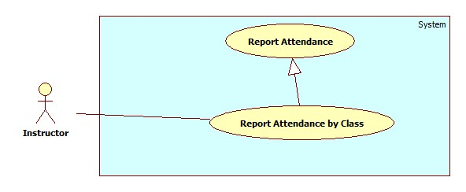

Figure 39: <Instructor> Report Attendance by Class

|  |  |  |  |
| --- | --- | --- | --- |
| **USE CASE – IU004** | | | |
| **Use Case No.** | IU004 | **Use Case Version** | 2.0 |
| **Use Case Name** | Report Attendance by Class | | |
| **Author** | Nguyen Thanh Binh. | | |
| **Date** | 23/09/2013 | **Priority** | Normal |
| **Actor:** Instructor.  **Summary:**  This use case allows Instructor report attendance of all students by class.  **Goal:**  Instructor can report attendance of class.  **Triggers:**   * Instructor can report information of class: subject, student, attendance… * Instructor must do these step to view report result: * On Home page, click on link ”Report” in menu bar and Report page will be showed. * Then, in select box “Report by” choose type: Class. * Then, in drop down list “Name” chose the class name. * Click on button “Statistic”.   **Preconditions:**   * User must logged in the system with the role is Instructor.   **Post Conditions:**   * **Success**: A report attendance by class will be showed on screen. * **Fail:** System will not return any value. Transfer to error page or still in current page.   **Main Success Scenario:**   |  |  |  | | --- | --- | --- | | Step | Actor Action | System Response | | 1 | Click “Report” link in menu bar. | Redirect to Report Page, include 4 part:   * Drop down list “Report by” (value: Class, Student, Block, and Semester). * Drop down list “Name” (value: auto set based on drop down list Report by) * Button “Statistic” * Button “Export”. | | 2 | Choose “Class” in drop down list Report by. | System will auto set value based on type Class. | | 3 | Chose the class in drop down list “Name”. Click button “Statistic”. | System will show result attendance by class on screen.  System still in current “Report” page. |   **Alternative Scenario:** N/A  **Exceptions:** N/A  **Relationships:** Manage Report Attendance.  **Business Rules:**   * System will show attendance result in chosen conditions. * Default value when manager clicks on tab “Report” is: Class. | | | |

Table 33: <Instructor> Report Attendance by Class

#### <Student>Overview Use Case

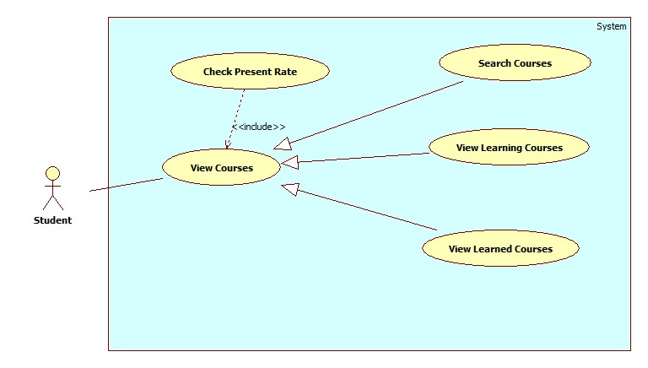

Figure 40: <Student> Overview Use Case

##### <Student>Check Present Rate by Searched Course

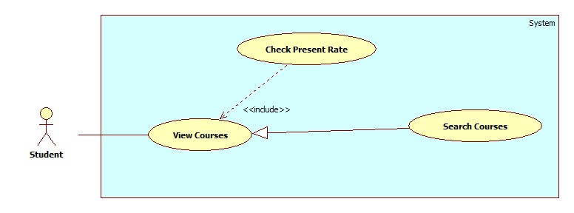

Figure 41: <Student> CheckPresent Rate

|  |  |  |  |
| --- | --- | --- | --- |
| **USE CASE – STU001** | | | |
| **Use Case No.** | STU001 | **Use Case Version** | 2.0 |
| **Use Case Name** | Check Present Rate by Searched Course | | |
| **Author** | Nguyen Thanh Binh | | |
| **Date** | 23/09/2013 | **Priority** | Normal |
| **Actor:** Student.  **Summary:**   * Student uses this case to search learned/learning course.   **Goal:**   * Allow student views learned/learning course info. The search condition is course name.   **Triggers:**   * Student can search course name on list course page. The searching results follow course name. * On list courses page, student choose search condition and clicks search button. System will show list search in list course table at current page. * On list search page, student choose the course. System will show information detail about that course.   **Preconditions:**   * User must logged in the system with the role is Student.   **Post Conditions:**   * **Success**: The search course will be found. System will show list search in lists course page. * **Fail:** System will transfer to error page or still in current page.   **Main Success Scenario:**   |  |  |  | | --- | --- | --- | | Step | Actor Action | System Response | | 1 | At lists course page, student choose search condition. | System will show the search condition include:  Course Name: text box | | 2 | After chose search condition, student clicks on search button (submit button) finish. | System will show list search of courses that student searched by condition in List Course table.  List Courses table includes 5 column: No (number), Course Name, Semester, Time, Present Rate. | | 3 | Ai list course table, student choose the course they want to view and click on that course name. | System will show information about that course in current page.  Information course includes: Roll call, Course Name, Semester, Time, Student Name & Code, Present, Present Rate and Detail (about exactly day present or absent) |   **Alternative Scenario:** N/A  **Exceptions:**   |  |  |  | | --- | --- | --- | | Step | Actor Action | System Response | | 1 | Search not found | System will show “No course was found!” |   **Relationships:** Check Present Rate  **Business Rules:**   * The courses will be search by course name. * Student can use search course to view their course easily. | | | |

Table 34: <Student> CheckPresent Rate

##### <Student>Check Present Rate by Learned Course

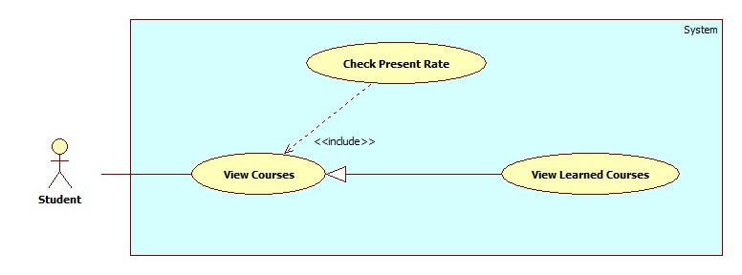

|  |  |  |  |
| --- | --- | --- | --- |
| **USE CASE – STU002** | | | |
| **Use Case No.** | STU002 | **Use Case Version** | 2.0 |
| **Use Case Name** | Check Present Rate by Learned Course | | |
| **Author** | Nguyen Thanh Binh | | |
| **Date** | 23/09/2013 | **Priority** | Normal |
| **Actor:** Student.  **Summary:**   * Student uses this case to search learned course.   **Goal:**   * Allow student views learned course info. The search condition is semester.   **Triggers:**   * On list learned courses page, student choose search condition. System will show list search in list course table at current page. * On list search page, student choose the course. System will show information detail about that course.   **Preconditions:**   * User must logged in the system with the role is Student.   **Post Conditions:**   * **Success**: The search course will be found. System will show list search in lists course page. * **Fail:** System will transfer to error page or still in current page.   **Main Success Scenario:**   |  |  |  | | --- | --- | --- | | Step | Actor Action | System Response | | 1 | At lists course page, student choose search condition. | System will show the search condition include:  Semester: drop down list | | 2 | After chose search condition, student view list learned course will be show on current page. | System will show list search of courses that student searched by condition in List Course table.  List Courses table includes 5 column: No (number), Course Name, Semester, Time, Present Rate. | | 3 | Ai list course table, student choose the course they want to view and click on that course name. | System will show information about that course in current page.  Information course includes: Roll call, Course Name, Semester, Time, Student Name & Code, Present, Present Rate and Detail (about exactly day present or absent) |   **Alternative Scenario:** N/A  **Exceptions:** N/A  **Relationships:** Check Present Rate  **Business Rules:**   * The learned courses will be search by semester. * Student can use search course to view their course easily. | | | |

##### <Student>Check Present Rate by Learning Course

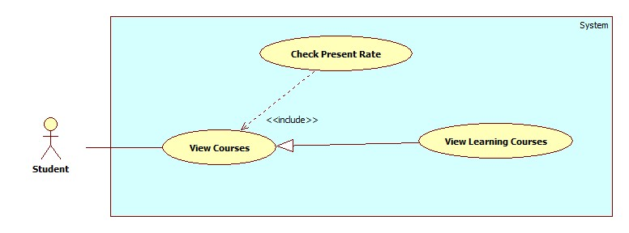

|  |  |  |  |
| --- | --- | --- | --- |
| **USE CASE – STU003** | | | |
| **Use Case No.** | STU003 | **Use Case Version** | 2.0 |
| **Use Case Name** | Check Present Rate by Learning Course | | |
| **Author** | Nguyen Thanh Binh | | |
| **Date** | 23/09/2013 | **Priority** | Normal |
| **Actor:** Student.  **Summary:**   * Student uses this case to search learning course.   **Goal:**   * Allow student views learning course info.   **Triggers:**   * On list learning courses page student choose the course. System will show information detail about that course.   **Preconditions:**   * User must logged in the system with the role is Student.   **Post Conditions:**   * **Success**: The search course will be found. System will show list search in lists course page. * **Fail:** System will transfer to error page or still in current page.   **Main Success Scenario:**   |  |  |  | | --- | --- | --- | | Step | Actor Action | System Response | | 1 | Student choose view Learning Course page. | System will show list learning courses. List Courses table includes 5 column: No (number), Course Name, Semester, Time, Present Rate. | | 2 | Ai list course table, student choose the course they want to view and click on that course name. | System will show information about that course in current page.  Information course includes: Roll call, Course Name, Semester, Time, Student Name & Code, Present, Present Rate and Detail (about exactly day present or absent) |   **Alternative Scenario:** N/A  **Exceptions:** N/A  **Relationships:** Check Present Rate  **Business Rules:**   * Student can use search course to view their course easily. | | | |

#### <Guest>Overview Use Case

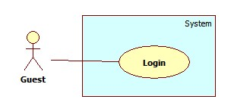

Figure 42: <Guest> Overview Use Case

##### <Guest> Login

Use Case Diagram



Figure 43: <Guest> Login

Use Case Specification

|  |  |  |  |
| --- | --- | --- | --- |
| **USE CASE – GU001** | | | |
| **Use Case No.** | GU001 | **Use Case Version** | 2.0 |
| **Use Case Name** | Login | | |
| **Author** | Pham Huy Hoang | | |
| **Date** | 19/09/2013 | **Priority** | Normal |
| **Actor:** Guest.  **Summary:**  Guest use this case to login into system.  **Goal:**  Allow authentication and authorization of the system.  **Triggers:**   * Guest want to login into system. * To login: Guest go to the login page, guest enter username and password, then click on “Log in” button to login.   **Preconditions:** N/A.  **Post Conditions:**   * **Success:** Guest is authorized, redirect to corresponding page. * **Fail:** System will show error on current page   **Main Success Scenario:**   |  |  |  | | --- | --- | --- | | Step | Actor Action | System Response | | 1 | Guest go to login page. | System show a login form, includes:   * Username: textbox (min length: 5, max length: 30, required). * Password: textbox (password box, min length:5, max length: 30, required). * Login: button. | | 1 | Guess enter username and password into textboxs.  Press “Log In” button. | Guest is logged into system, authorized with corresponding role. Redirect to corresponding page..  [Exception 1,2] |   **Alternative Scenario:** N/A  **Exceptions:**   |  |  |  | | --- | --- | --- | | No | Actor Action | System Response | | 1 | No input in “Username” or “Password” textboxs | Show error message: “Please enter username/password” below Username/Password textbox. | | 2 | Username/Password not in range [5,30] | Show error message: “Username/Password must be from 5 to 30 characters” textbox. | | 3 | Input invalid “Username” and “Password” | Show error message: “Invalid username or password”. |   **Relationships:** N/A  **Business Rules:**   * Each student, instructor, staff, admin has an account. * Only active account can log in. * Only instructor’s account can log in into mobile app. | | | |

Table 35: <Guest> Login

#### <Authorized User> Overview Use case

##### < Authorized User> Overview Use Case

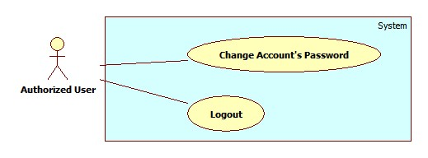

Figure 44: < Authorized User> Overview Use Case

##### < Authorized User> Change Password

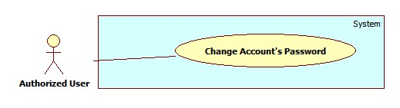

Figure 45: < Authorized User> Change Password

|  |  |  |  |
| --- | --- | --- | --- |
| **USE CASE – UU001** | | | |
| **Use Case No.** | UU001 | **Use Case Version** | 2.0 |
| **Use Case Name** | Change Password | | |
| **Author** | Nguyen Thanh Binh | | |
| **Date** | 23/09/2013 | **Priority** | Normal |
| **Actor:** User (Instructor, Staff, Student, Admin).  **Summary:**   * User users this case to change their password.   **Goal:**   * Allow users can change their password.   **Triggers:**   * User use this use case to help improve their account security. * User login their account, click “Change Password” link. Go to “Change Password” page.   **Preconditions:**   * User must logged in the system with the role is User (Staff, Instructor, Student, Admin).   **Post Conditions:**   * **Success**: The password be changed. * **Fail:** System will transfer to error page or still in current page.   **Main Success Scenario:**   |  |  |  | | --- | --- | --- | | Step | Actor Action | System Response | | 1 | User selects the “Change Password” command in the top-right column of Home page. | System will show “Change Password” page includes:   * Username – Text box * Current Password – Text box * New Password – Text box * Confirm New Password – Text box * Submit – Button * Reset - Button | | 2 | - User enters the following information (Username, Current Password, New password, Confirm new password).  - Click “Submit” button to send request. | * System changes the user’s password. * System automatically re-authenticates the user with the new credentials. * System will show “Your password was changed successfully!” |   **Alternative Scenario:** N/A  **Exceptions:**   |  |  |  | | --- | --- | --- | | Step | Actor Action | System Response | | 1 | System verifies that the Username and Current Password entries are correct and correspond to a current user. | System will show “Wrong username/ password” and reset all. | | 2 | New password same current password | System will show “New password was used! Please choose new password” and reset all. | | 3 | New password and confirm new password does not match. | System will show “Password does not match” and reset all. |   **Relationships:**  **Business Rules: N/A** | | | |

Table 36: < Authorized User> Change Password

##### < Authorized User>Logout

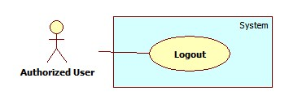

Figure 46: < Authorized User> Logout

|  |  |  |  |
| --- | --- | --- | --- |
| **USE CASE – UU002** | | | |
| **Use Case No.** | UU002 | **Use Case Version** | 2.0 |
| **Use Case Name** | Change Password | | |
| **Author** | Nguyen Thanh Binh | | |
| **Date** | 23/09/2013 | **Priority** | Normal |
| **Actor:** User (Instructor, Staff, Student, Admin).  **Summary:**   * User use this use case to logout system.   **Goal:**   * The user selects the option to log off of the HCPT website and is then redirected back to the Login page.   **Triggers:**   * The use case starts when the user selects the option to logout. * The user selects the option to logout. * The system informs the user of logging out. * The user confirms logging out. * The system redirects user back to the Login page.   **Preconditions:**   * User must logged in the system with the role is User (Staff, Instructor, Student, Admin).   **Post Conditions:**   * **Success**: User logout system and redirect to login page. * **Fail:** System will transfer to error page or still in current page.   **Main Success Scenario:**   |  |  |  | | --- | --- | --- | | Step | Actor Action | System Response | | 1 | The user selects log out. | The system will show a pop-up: Do you really want to logout”   * Yes: button * No: button | | 2 | User select “Yes”.  [Alternative 1] | The system will clear user session and the user is logged out |   **Alternative Scenario:**   |  |  |  | | --- | --- | --- | | Step | Actor Action | System Response | | 1 | User selects No. | User stay at current page. |   **Exceptions:** N/A  **Relationships:** N/A  **Business Rules:** N/A | | | |

Table 37: <User> Logout

## Software System Attribute

### Usability

#### Graphic User Interface

* All the text, label and image in staff, instructor and student page should be English.
* All the text, label and image in admin page should be English.

#### Usability

* Website admin, staff and instructor should need more than one week of training to be productive with the system.
* The student can use the system easily without training.

#### Installation

* The system must be easy to deploy. Customer can deploy successfully and learn to configure, maintain the system within one day of training.
* The mobile app must be easy to install. Compatible with almost Android Phone.
* The attached manual guide must be clear. User can read and do themselves without developer’s help.

### Reliability

* N/A

### Availability

* N/A

### Security

* Privacy: Each role of user has a specific permission to interact with system.
* System always checks authorization and authenticated before doing anything.
* Only admin can grant permission to staff.

### Maintainability

* N/A

### Portability

* N/A

### Performance

* Detect Faces From an Image: 3~4 seconds/image.
* Recognize Faces: 20~30 seconds/100 faces. With training set of 30 students, 600 images.
* The image upload speed depend on the speed of the network.

## ERD

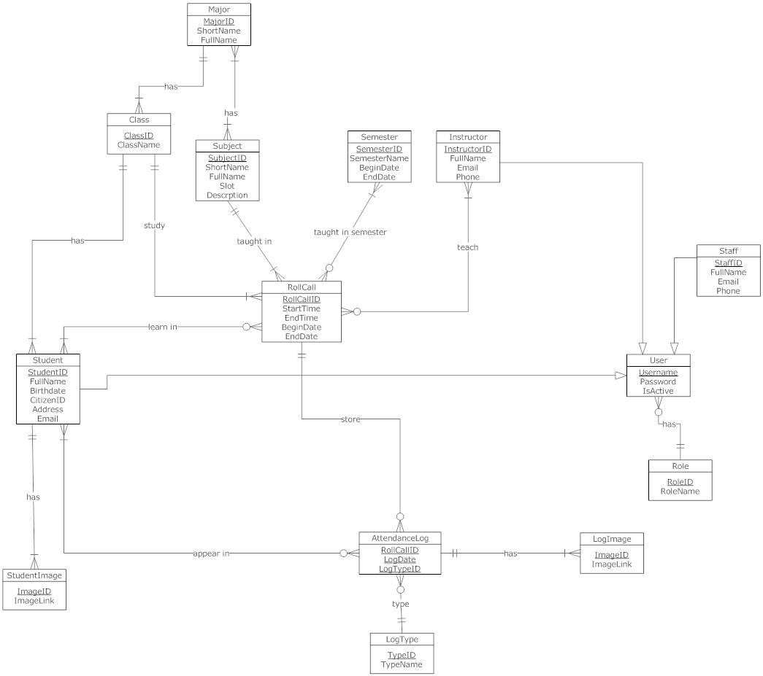

Figure 47: ERD - Conceptual Diagram